Descriptive statistics using JAMOVI
CONTENTS
1. Importing the database from an Excel file into Jamovi 1
1.1 Opening the Excel file 1
1.2 Verifying the imported database 2
1.3 Changing the variable type 2
1.4 Setting the number of decimal places 2
1.5 Saving the database in Jamovi format 3
2. Creating a frequency table for ONE QUALITATIVE VARIABLE 3
2.1 Creating the frequency table 3
2.2 Reading the frequency table 4
2.4 Interpreting the frequency table 4
3. Creating a chart for ONE QUALITATIVE VARIABLE 4
3.1 Creating the bar chart 5
3.2 Interpreting the chart 5
4. Creating the contingency table for TWO QUALITATIVE VARIABLES 5
4.1. Creating the contingency table 6
5. Create a 100% stacked column chart 6
5.1 Choosing the type of chart 6
5.2 Creating a 100% stacked column chart 7
5.3 Interpreting the charts 7
6. Calculating descriptive statistics for QUANTITATIVE VARIABLES 8
6.1 Calculating the indicators 8
6.2 Interpreting the table 9
7. Creating a chart for ONE QUANTITATIVE VARIABLE 9
7.1 Creating a histogram 9
7.2 Interpreting the histogram 10
7.3 Creating a box-and-whisker plot 10
7.4 Interpreting the box-and-whisker plot 11
8. Creating a chart for TWO QUANTITATIVE VARIABLES (SCATTER PLOT) 11
8.1 Creating the scatter plot 11
9. Calculating descriptive statistics BY SUBGROUP 12
9.1 Calculating the indicators for each subgroup 12

1. Importing the database from an Excel file into Jamovi

1.1 Opening the Excel file
Step 1. Open the Search Bar on your computer, type Jamovi and select Jamovi version 2.7.38 from the search results.
Step 2. Launch Jamovi and locate the main menu button (☰ ) in the top-left corner of the window.
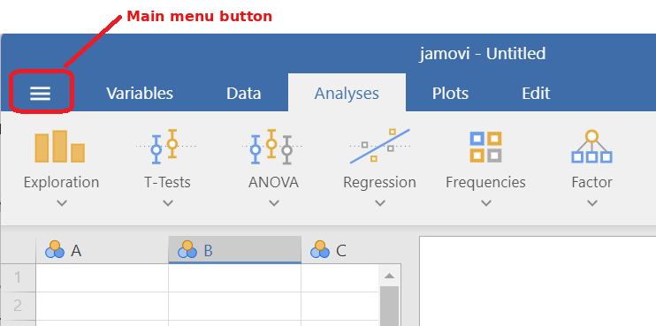
Step 3. Click the main menu button ☰ and select Open → select This PC → click Browse (top-right corner) and navigate to the folder where you saved the Excel file (e.g. the Desktop).
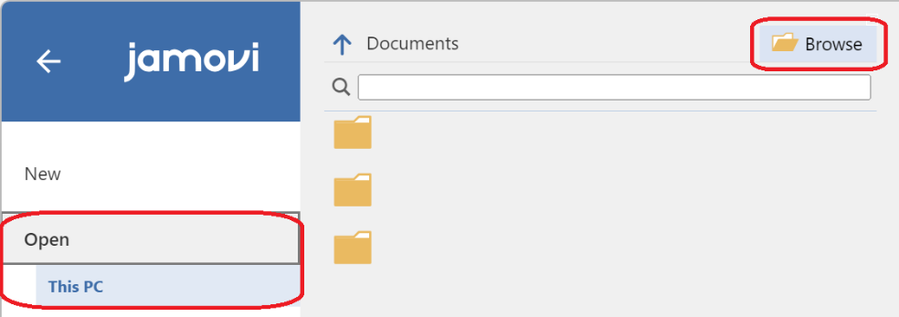
Step 4. Select the Excel file you need (e.g. LP05_BD_Hepatitis.xlsx) → click Open.
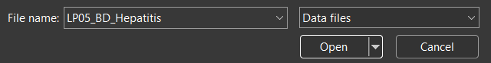
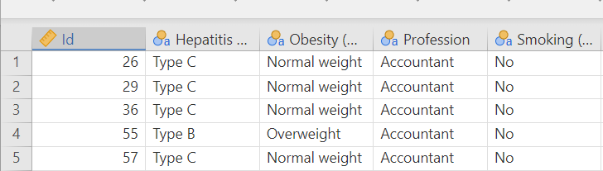
Note: The data will appear in the spreadsheet: each COLUMN is a variable, and each ROW is a patient.

Verifying the imported database
Step 5. Select the Data tab and verify that:
(1) all the variables from the Excel file appear as columns;
(2) the number of rows equals the number of patients in the study;
(3) the icon next to each variable name shows the correct measurement level (see Figure 4).
Important: Jamovi often assigns the measurement type incorrectly, so check every variable.

1.3 Changing the variable type
Step 6. Double-click on the variable name (the column header). The variable setup panel opens above the data.
Step 7. Find the Measure type property → select the appropriate type: Nominal, Ordinal, Continuous or ID (see Table 1). Check that the values and the category labels are correct.
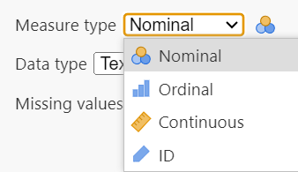
Note: For ORDINAL variables, check that the categories are listed in their natural order (e.g. normal weight → overweight → obese). If they are not, select a category in the Levels list and move it with the up/down arrows.
Step 8. Close the Setup panel with the arrow (↑) in its top-right corner or move on to the next variable with the arrows at the top of the panel.
Table 1. Recommended measurement type in Jamovi for the variables used in this study.
Variable | Measure type in Jamovi
Patient ID | ID
Sex, Smoker, Hepatitis type, Profession, Symptoms at discharge, Hypertension | Nominal
Obese (normal weight / overweight / obese), Risk factor score | Ordinal
Age, Weight, Height, Heart rate, SBP, DBP, Blood glucose, Cholesterol, Triglycerides, HDL | Continuous
Note: In Jamovi, Continuous is used for all quantitative variables, including discrete ones.

1.4 Setting the number of decimal places
Path: ⋮ (top-right corner) → Results → Number format
Step 9. Click the ⋮ button (three vertical dots) in the top-right corner of the Jamovi window. The settings panel opens (see Figure 5).
Step 10. In the Results section, open the Number format drop-down list and choose the format you need:
- dp (decimal places) – the number of digits after the decimal point, e.g. 2 dp - 0.33;
- sf (significant figures) – the total number of meaningful digits, e.g. 3 sf - 0.327.
For the reports in this practical activity, choose a 3 dp format.
Step 11. Under Decimal symbol, choose Dot (e.g. 66.0%)
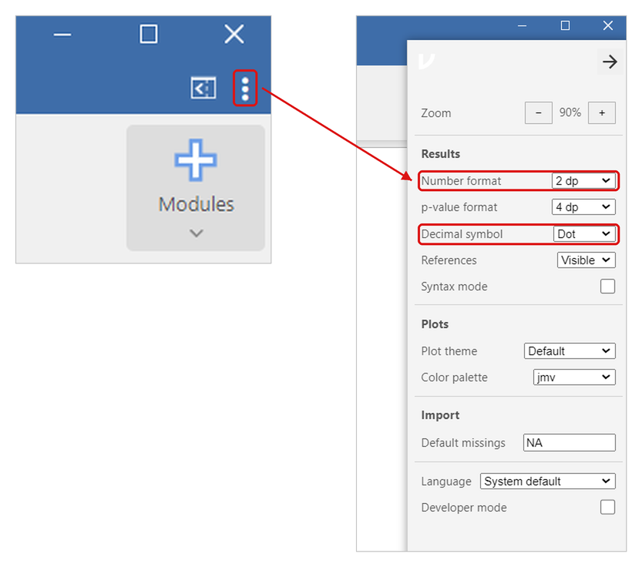
Note: The new format is applied immediately to all the tables in the results panel. Set it BEFORE copying the tables into Report PA05_ LF.docx, so that all the values in the report have the same number of decimals.

1.5 Saving the database in Jamovi format
After you complete the statistical analysis, save the file in Jamovi’s own format (.omv). This keeps the measurement levels and all your analyses.
Path: ☰ → Save As → Browse → file_name.omv → Save
Example: Save the file as Hepatitis_study.omv and next time, open this .omv file instead of importing the Excel file again.

2. Creating a frequency table for ONE QUALITATIVE VARIABLE

2.1 Creating the frequency table
Example: We want to analyse the distribution of Hepatitis type, then of Symptoms at discharge.
Step 1. Analyses tab → Exploration → Descriptives
Step 2. In the list on the left, select Hepatitis type and move it with the arrow (→) into the Variables box → do the same for Symptoms at discharge.
Step 3. Leave the Split by box empty, because each table is built for a single variable.
Step 4. Select Frequency tables (below the Split by box). This option works for nominal and ordinal variables.
Important: From the Statistics section, DO NOT select the mean, standard deviation or variance options, etc.; they have no meaning for a nominal variable.
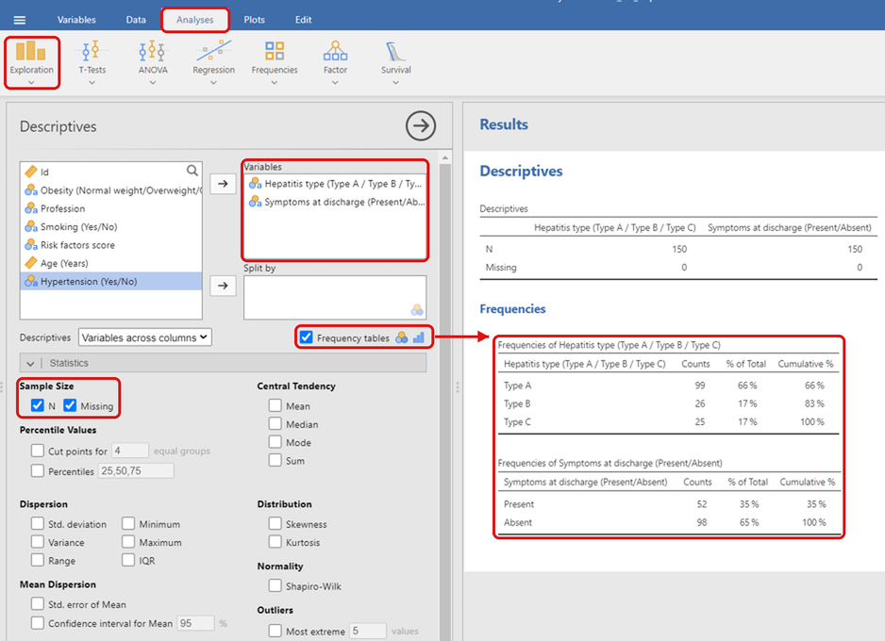

2.2 Reading the frequency table
Jamovi generates one frequency table for each variable, with the following columns:
- Counts – the absolute frequency (number of patients in each category);
- % of Total – the relative frequency (percentage of patients in each category);
- Cumulative % – the ascending cumulative relative frequency.
Step 5. Right-click on the table in the results panel (right side of the screen) and choose Copy → paste it (Ctrl + V) into the Word file Report PA05_ LF.docx.
Step 6. Write the title of the table above the table, e.g. Table 1. Frequency table for hepatitis type.

2.4 Interpreting the frequency table
In Report PA05_ LF.docx, write the interpretation below each table.
Example: Table 1 shows that hepatitis type A was the most frequent category (66.0%), followed by type B (17.3%) and type C (16.7%).

3. Creating a chart for ONE QUALITATIVE VARIABLE

3.1 Creating the bar chart
Example: We want to analyse the distribution of Symptoms at discharge.
Step 1. Plots → Bar Plot
Step 2. Make sure Variable type is set to Categorical.
Step 3. Move the qualitative variable (e.g. Symptoms at discharge (Present / Absent)) into the Categorical Variable field → leave Grouping Variable empty.
Important: Jamovi generates the chart automatically (without a frequency table).
Step 4. Under General Options → Bar, select Value labels (the frequencies appear on the bars).
Step 5. Under Group Options → Bar Type, select Grouped.
Step 6. Under Plot & Axis Titles, open the Plot Title tab and type the chart title in the Title text field → open the X-Axis Title tab and type the title of the horizontal axis → open the Y-Axis Title tab and type the title of the vertical axis.
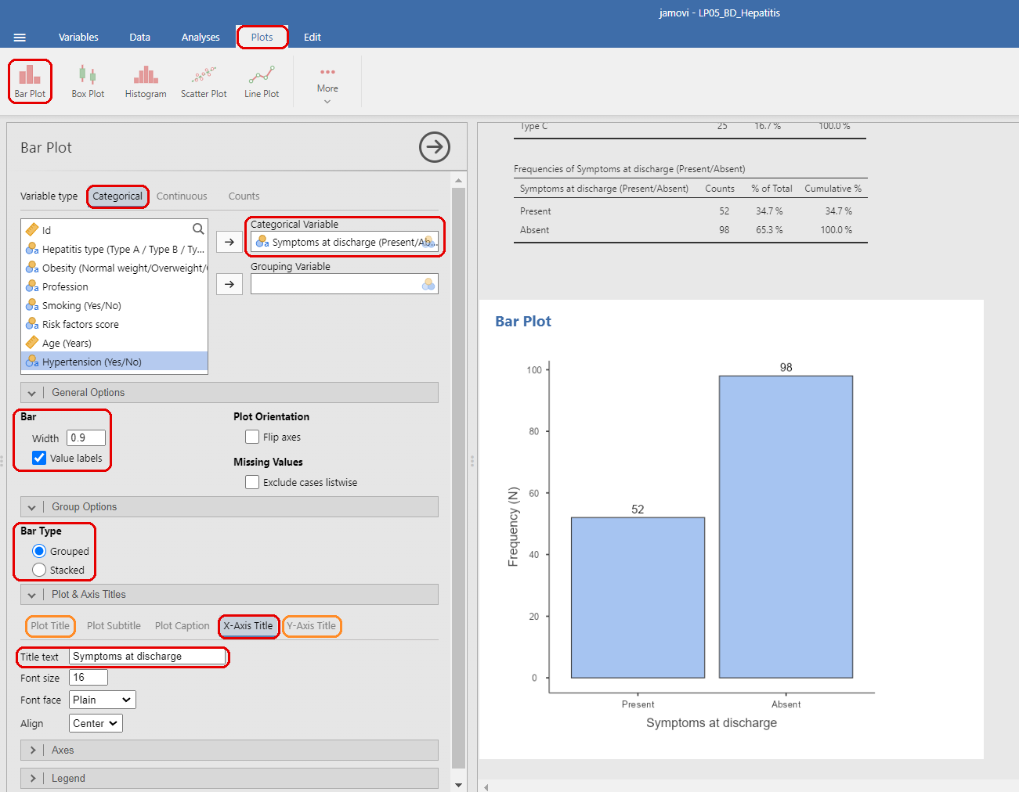
Step 7. Right-click on the chart in the results panel (right side of the screen) and choose Copy → paste it (Ctrl + V) into the Word file Report PA05_ LF.docx.
Step 8. Write the figure title BELOW the chart, e.g. Figure 1. Distribution of patients by symptoms at discharge.

3.2 Interpreting the chart
In Report LP5_ NP.docx, write the interpretation below the chart.
Example: Figure 1 shows the distribution of patients by symptoms at discharge. The number of patients without symptoms (98) was higher than the number of patients with symptoms (52)4. Creating a contingency table for TWO QUALITATIVE VARIABLES

4. Creating the contingency table for TWO QUALITATIVE VARIABLES

4.1. Creating the contingency table
Example: We want to analyse the relationship between Smoking and Obesity.
Step 1. Analyses → Frequencies → Independent Samples – χ² test of association
Note: This option generates the contingency table for two qualitative variables measured on independent observations.
Step 2. Move the Smoking (Yes / No) variable into the Rows field.
Step 3. Move the Obesity (normal weight / overweight / obese) variable into the Columns field.
Note: Jamovi generates the table automatically.
Step 4. Open the Cells section and select Observed counts, plus Row or Column percentages, depending on the question:
- To find the proportion of a characteristic within each category of the column variable, select Column percentages.
- To find the proportion within each category of the row variable, select Row percentages.
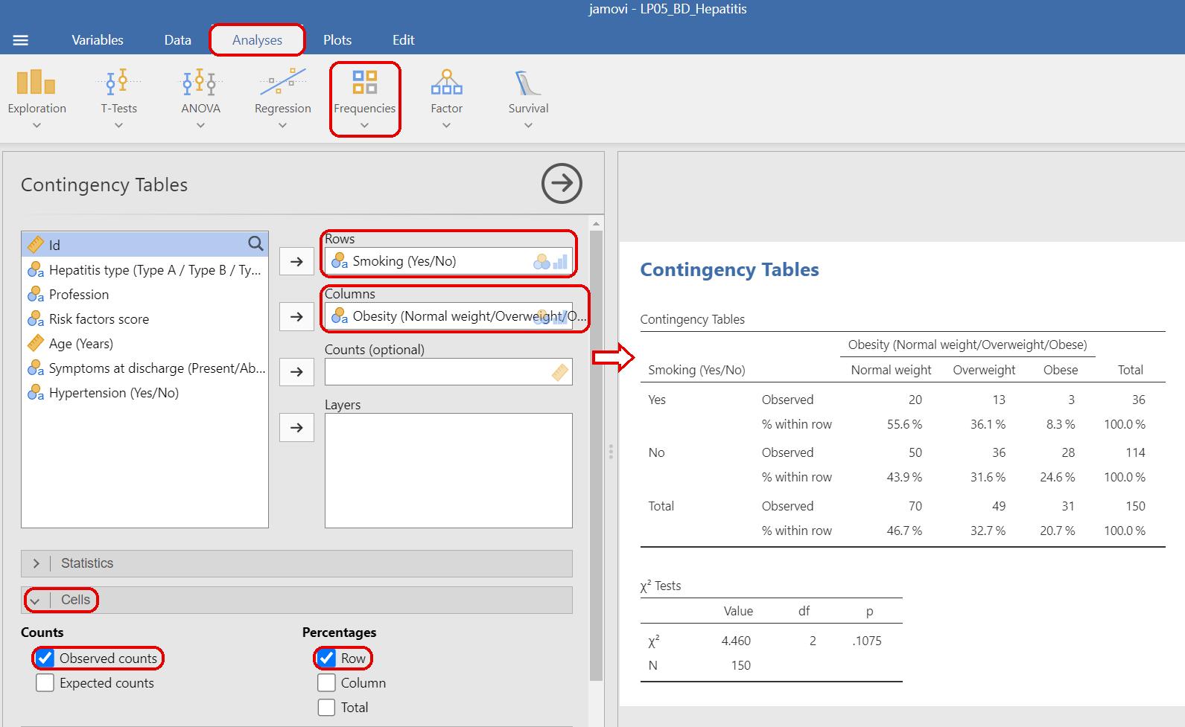
Step 5. Right-click on the table in the results panel (right side of the screen) and choose Copy → paste it (Ctrl + V) into the Word file Report PA05_ LF.docx.
Step 6. Write the title above the table → write the interpretation below the table.5. Creating a chart for TWO QUALITATIVE VARIABLES

5. Create a 100% stacked column chart

5.1 Choosing the type of chart
Grouped columns (Side by side) | Stacked columns (Stacked) | 100% stacked columns
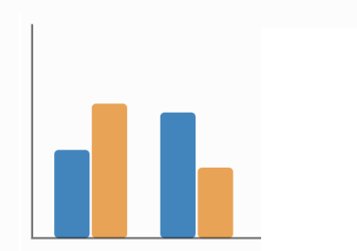 | 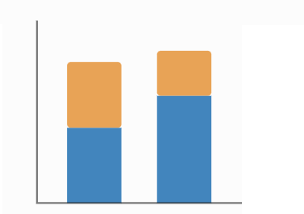 | 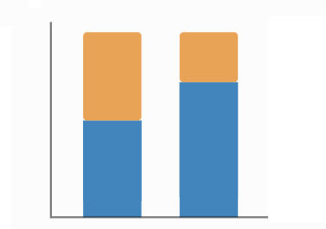
Compares the categories directly, using columns placed next to each other. | Shows how much each category contributes to the total. | Each column represents 100%, which makes it easy to compare percentages.
Note: To analyse the relationship between two qualitative variables, the 100% STACKED COLUMN chart is often the most useful option, especially when the groups are different sizes.

5.2 Creating a 100% stacked column chart
Example: We want to analyse the relationship between Smoking and Obesity.
Step 1. Analyses → Frequencies → Independent Samples – χ² test of association
Step 2. Rows: Smoking (Yes / No) → Columns: Obesity (normal weight / overweight / obese).
Step 3. Open the Plots section and select Bar Plot → Under Bar Type, select Stacked.
Step 4. Under Y-Axis, select Percentages and, in the drop-down list, within rows → Under X-Axis, select Rows, so that each bar represents one category of the row variable.
Each bar now represents 100% of the patients in that smoking category (smokers / non-smokers), divided by weight category (see Figure 11).
Note: "Within rows" means that the percentages are calculated from the total of each row. If you put the variable whose groups you want to compare on Columns instead, select within columns and X-Axis: Columns.
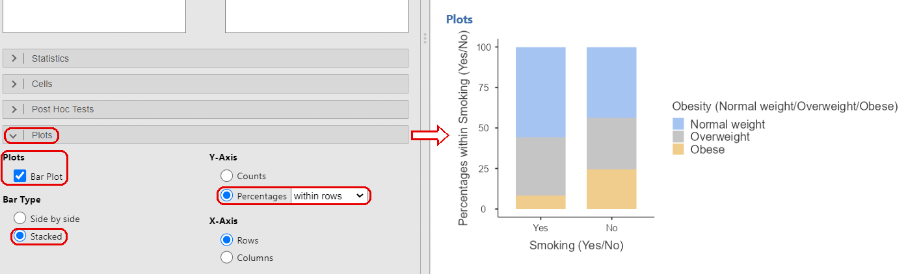
Important: This chart cannot be edited: you cannot add titles or value labels, and you cannot change the language of the labels. Write the figure title in Word, below the chart.
Step 5. Right-click on the chart in the results panel (right side of the screen) and choose Copy → paste it (Ctrl + V) into the Word file Report PA05_ LF.docx.
Step 6. Write the figure title below the chart. For the 100% stacked chart, the title can only be added in Word.

5.3 Interpreting the charts
In Report PA05_ LF.docx, write the interpretation below each chart.
Example: Figure 2 shows the percentage distribution of weight categories by smoking status. The proportion of overweight or obese patients was higher among non-smokers (56.1%) than among smokers (44.4%).
Tip: Because the groups have very different sizes (114 non-smokers vs 36 smokers), absolute counts are not suitable for comparing the groups. Use the 100% stacked chart for comparisons.

6. Calculating descriptive statistics for QUANTITATIVE VARIABLES

6.1 Calculating the indicators
Important: For this analysis, import the LP05_BD-DateSpitalizare.xlsx file (see Chapter 1).
Example: We want the descriptive statistics of Age (years), Weight (kg) and Cholesterol (mg/dL).
Step 1. Analyses → Exploration → Descriptives
Step 2. Move one or more quantitative variables (Age, Weight, Cholesterol) into the Variables field → leave Split by empty (for statistics by subgroup, see Chapter 9).
Step 3. Open the Statistics section and select the indicators listed in Table 2 (see Figure 13).
Table 2. Options to select in the Statistics section.
 | Section in Jamovi | Options to select | What you obtain
1. | Sample Size | N | Number of values
2. | Central Tendency | Mean, Median, Mode | Indicators of central tendency
3. | Dispersion | Std. deviation, Variance, Range, Minimum, Maximum | Indicators of dispersion; minimum and maximum
3. | Mean Dispersion | Std. error of Mean | Standard error of the mean
4. | Percentile Values | Percentiles – type 25,50,75 | Quartile 1 (25th), median (50th), Quartile 3 (75th)
5. | Distribution | Skewness, Kurtosis | Indicators of shape
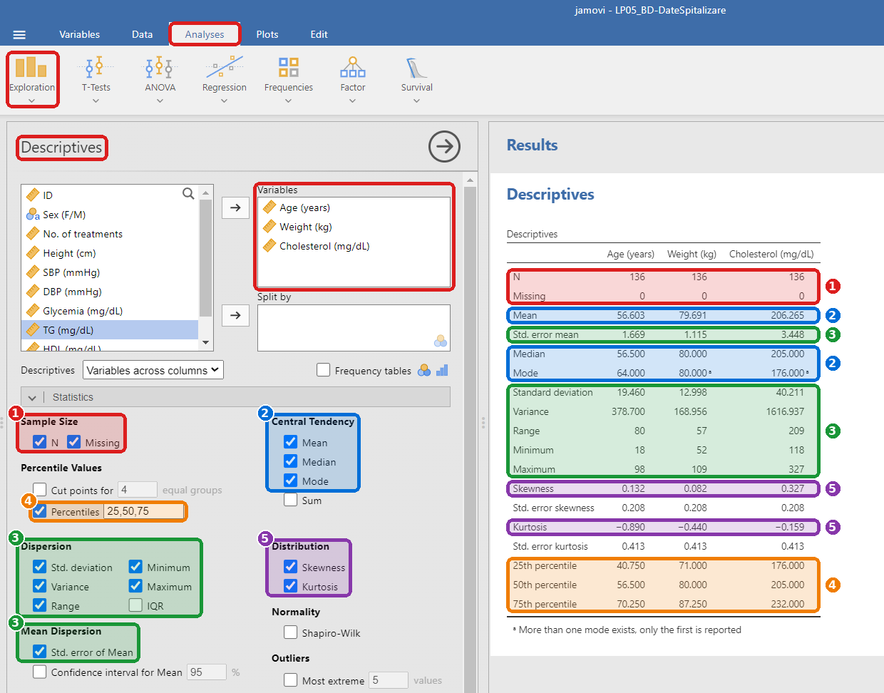
Note: If a variable has several modes, Jamovi reports only the first one and marks it with a footnote (ᵃ).

6.2 Interpreting the table
Step 4. Right-click on the table in the results panel (right side of the screen) and choose Copy → paste it (Ctrl + V) into the Word file Report PA05_ LF.docx.
Step 5. Write the table title above the table, e.g. Table 4. Calculation of statistical indicators.
Step 6. Write the interpretation of the indicators below the table.

7. Creating a chart for ONE QUANTITATIVE VARIABLE

7.1 Creating a histogram
Example: We want to analyse the distribution of Cholesterol.
Step 1. Plots → Histogram
Step 2. Variable: Cholesterol (mg/dL) → leave Grouping Variable empty.
Step 3. Under General Options → Density, select Show density (adds the density curve).
Step 4. Under Bin Width, leave Auto, or select Manual and type a bin width if you want a specific class width.
Step 5. Under Plot & Axis Titles, open the Plot Title tab and type the chart title in the Title text field → open the X-Axis Title tab and type the title of the horizontal axis → open the Y-Axis Title tab and type the title of the vertical axis.
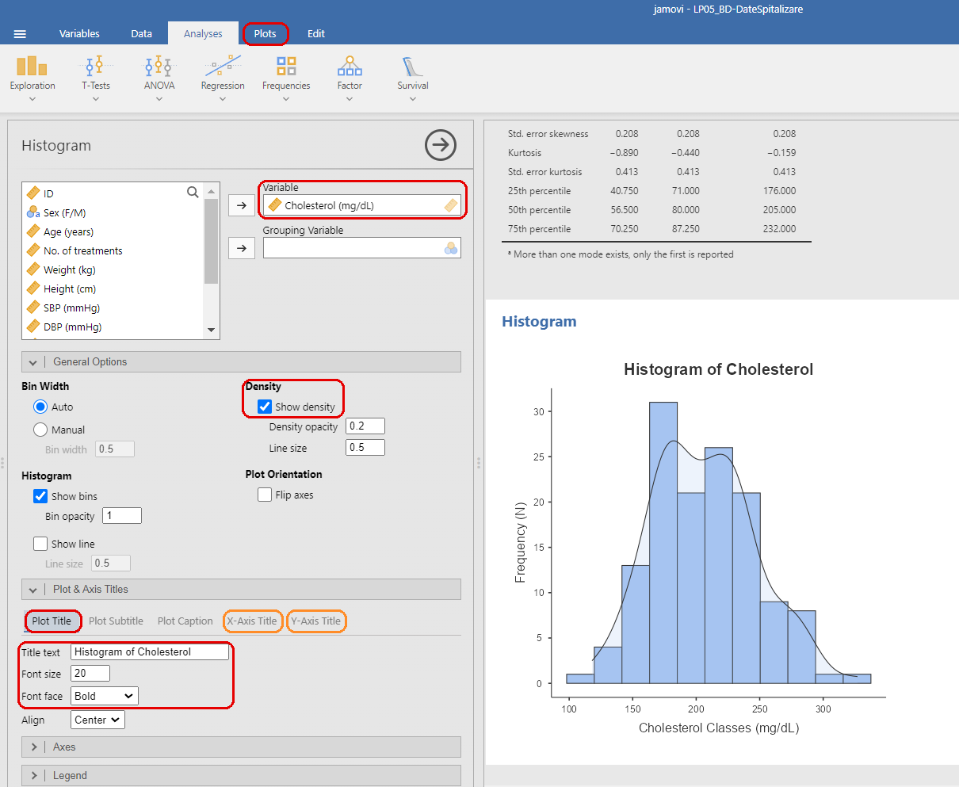
Step 6. Right-click on the chart in the results panel (right side of the screen) and choose Copy → paste it (Ctrl + V) into the Word file Report PA05_ LF.docx. Write the figure title below the chart.

7.2 Interpreting the histogram
Below the histogram, describe:
- the shape of the distribution (symmetric, positively skewed or negatively skewed);
- the number of peaks (unimodal or bimodal);
- the modal class (the class interval with the highest frequency);
- the approximate centre and spread of the values;
- any gaps or isolated values.
Check that your description agrees with the skewness and kurtosis values from Chapter 6.

7.3 Creating a box-and-whisker plot
Example: We want to analyse the distribution of Cholesterol by Sex.
Step 1. Plots → Box Plot
Step 2. Variable: Cholesterol (mg/dL) → Grouping Variable 1: Sex (F/M).
Step 3. Under General Options → Box Element, select Show outliers.
Step 4. Under Plot & Axis Titles, open the Plot Title tab and type the chart title in the Title text box → open the X-Axis Title tab and type the title of the horizontal axis → open the Y-Axis Title tab and type the title of the vertical axis
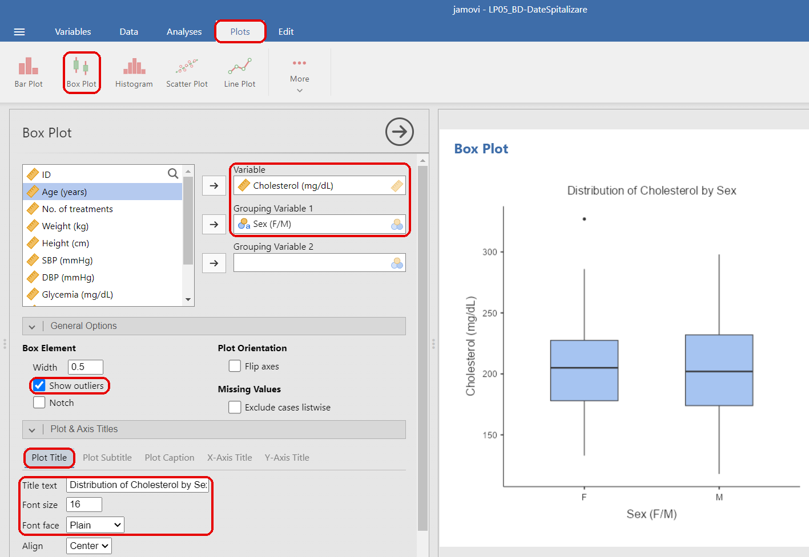
Step 5. Right-click on the chart in the results panel (right side of the screen) and choose Copy → paste it (Ctrl + V) into the Word file Report PA05_ LF.docx. Write the figure title below the chart.

7.4 Interpreting the box-and-whisker plot
How to read the box plot:
- The line inside the box is the median.
- The lower and upper edges of the box are Quartile 1 and Quartile 3; the height of the box is the interquartile range (IQR).
- The whiskers extend to the most extreme values that are not outliers.
- The points beyond the whiskers are outliers: values below Q1 − 1.5 × IQR or above Q3 + 1.5 × IQR.
Below the box-and-whisker chart in your Word file, compare the groups in terms of median, spread (box height) and outliers.

8. Creating a chart for TWO QUANTITATIVE VARIABLES (SCATTER PLOT)

8.1 Creating the scatter plot
Example: We want to analyse the relationship between Weight and Cholesterol.
Step 1. Plots → Scatter Plot
Step 2. X-Axis: Weight (kg) → Y-Axis: Cholesterol (mg/dL).
Step 3. Under General Options → Regression Line, select Show line and Method: Linear.
Step 4. Under Plot & Axis Titles, open the Plot Title tab and type the chart title in the Title text box → open the X-Axis Title tab and type the title of the horizontal axis → open the Y-Axis Title tab and type the title of the vertical axis
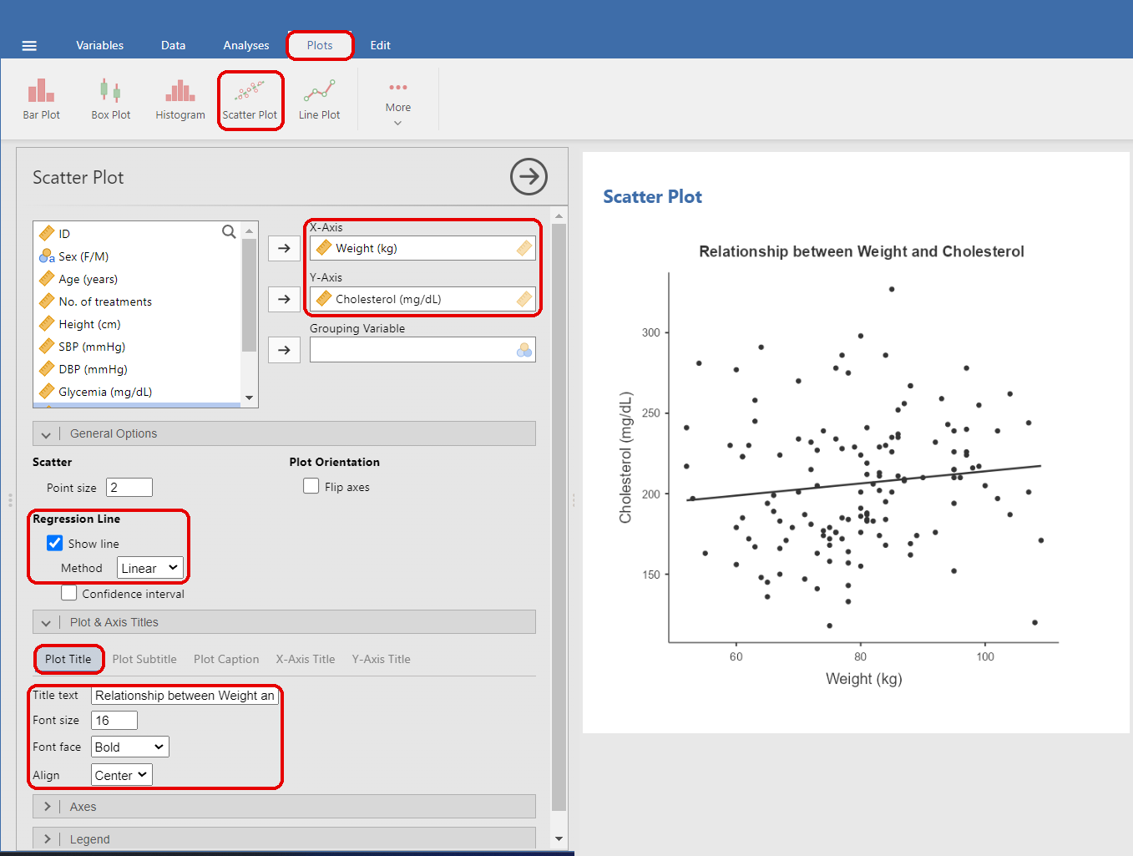
Step 5. Right-click on the chart in the results panel (right side of the screen) and choose Copy → paste it (Ctrl + V) into the Word file Report PA05_ LF.docx. Write the figure title below the chart.

9. Calculating descriptive statistics BY SUBGROUP

9.1 Calculating the indicators for each subgroup
Example: We want to calculate the descriptive statistics of Age, Weight and Cholesterol separately for women and men.
Step 1. Analyses → Exploration → Descriptives
Step 2. Variables: Age, Weight, Cholesterol → Split by: Sex (F/M).
Step 3. Open the Statistics section and select the same indicators as in Chapter 6 (Table 3).
Note: Jamovi reports each indicator separately for each subgroup (F and M).
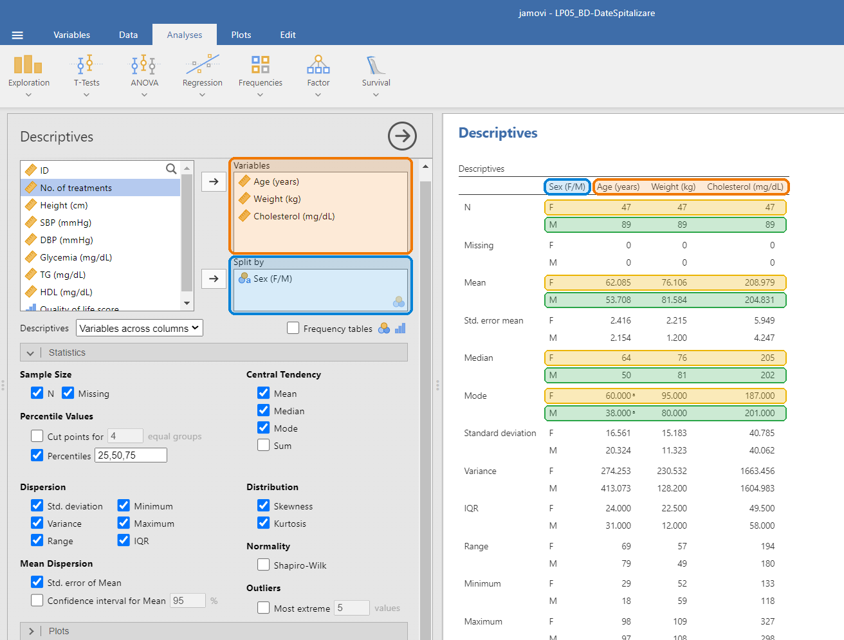
Tip: If the table is too wide, change the Descriptives drop-down list (below the variable list) from Variables across columns to Variables across rows.

