Statistical Analysis of Medical Data: Correlation and Regression Analysis – Hints
Scenario 1.

Interpreting the Pearson/Spearman correlation coefficient (r)
- To interpret the intensity of the linear relationship between two variables (quantitative with normal distribution) we use Colton's empirical rules for correlation coefficient [1]
  - If r $∈$ [-0.25 ; +0.25] → weak or non-existent linear correlation
  - If r $∈$ (0.25; 0.50] ∪ (-0.25 ;-0.50] → acceptable linear correlation
  - If r $∈$ (0.50; 0.75] ∪ (-0.50 ;-0.75] → moderate to good linear correlation
  - If r $∈$ (0.75; 1] ∪ (-0.75 ; -1] → strong linear correlation (very good)
[Colton T. Statistics in Medicine. Little Brown and Company, New York, NY, 1974]
- Interpretation of the sign of the correlation coefficient between two variables (quantitatives with normal distribution)
  - If r>0 → between the two variables there is a relationship of direct proportionality (when the value of one of them increases, the value of the other also increases), a positive relationship
  - If r<0→ between the two variables there is a relationship of inverse proportionality (when the value of one of them increases, the value of the other decreases), a negative relationship
- Interpretation of p
Null hyphotesis H0: The coefficient of correlation is not statistically significant different from zero
Alternative hyphotesis H1: The coefficient of correlation is statistically significant different from zero

  - p<0.05, we reject the null hyphotesis H0 and accept the alternative hyphothesis H1. Conclusion: there is a statistically significant correlation between the tested variables (the coefficient of correlation is statistically significant different from zero)
  - p≥0.05, we fail to reject null hyphotesis. Conclusion: there is no statistically significant correlation between the tested variables (the coefficient of correlation is not statistically significant different from zero)

Scenario 2.
3. Scatter chart in Jamovi
In menu Analyses, go to Exploration – Scatterplot
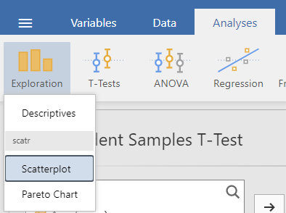
Move on X axis the independent variable (if there is an assosiation, the risk factor is the independent variable). Move on Y axis the dependent variable (if there is an assosiation, the disease is the dependent variable).
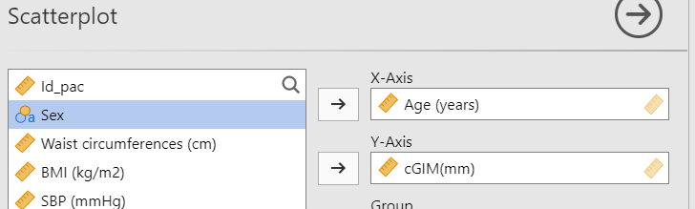
Add a regression line linear to the chart.
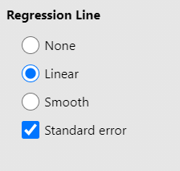
The chart will look like:
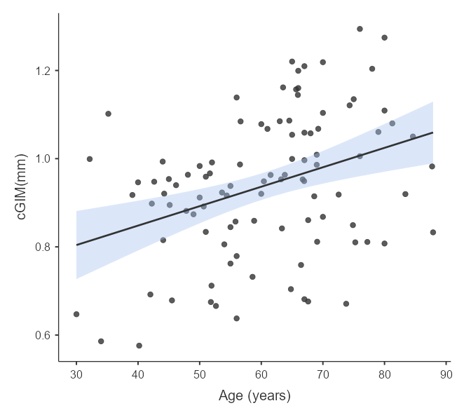
Copy the chart in word and interpret it.
  - Interpretation of Scatter: split the scatter plot in 4 cadres using the mean of X and the mean of Y:
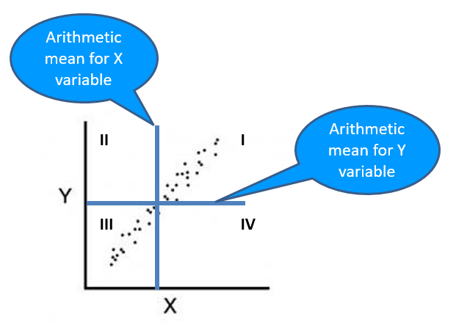
If a linear relationship exists between X and Y, the markers of the plot will be in cadres II and IV (negative direction – descendant trend) or I and III (positive direction – ascendant trend). If the markers are uniformly dispersed in all four cadres, the scatter indicates a null relationship between X and Y.
- Interpretation of the trend of the regression line Y=aX+b, where X, Y are two quantitative normal distributed variables
  - The trend is ascending→ between the two variables there is a relationship of direct proportionality (when the value of one of them increases, the value of the other also increases) → a>0
  - The trend is descending → between the two variables there is a relationship of inverse proportionality (when the value of one of them increases, the value of the other decreases) → a<0
The lines correspond to the arithmetic means:
Age 60.6
cGIM 0.94

Chart interpretation:
The points of the diagram are preferentially distributed in quadrants I and III. The dependence between age and cGIM is positive: an increase in age implies an increase in cGIM. The regression line has an ascending trend (increasing trend). The slope of the regression line is positive.
Conclusion: The regression line suggests that cGIM is correlated with the age.

6. Calculating the correlation coefficient between two quantitative variables using Jamovi application.
In menu Analyses, go to Regression – Correlation matrix
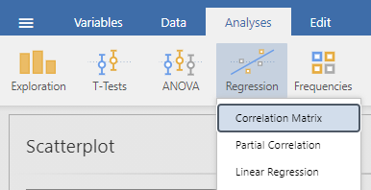
Select the quantitative variables for which you want to see the coeficient of correlation.
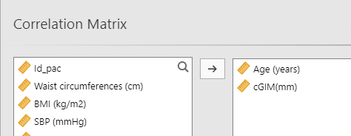
Choose the appropiate coeficient of correlation:
- Pearson if both variables are normally distributed and the assosiation is linear.
- Spearman if one or both variables are not normally distributed or the assosiation is non-linear.


