Statistical tests for frequencies
Daniel-Corneliu Leucuța, Cosmina Bondor

SOLUTIONS
1. Formulating hyphotesis
Choose one of these possible null hyphotesis/alternative hyphotesis (all are :
Null hypothesis H0:
- There is no statistically significant association between treatment with methylprednisolone / dexamethasone and hyperglycemia in subjects with COVID-19
- There is no statistically significant difference between the frequency of hyperglycemia in subjects with COVID-19 who received methylprednisolone and those who received dexamethasone.
- Treatment with methylprednisolone / dexamethasone and hyperglycemia are independent in subjects with COVID-19.
Alternative hypothesis:
- There is a statistically significant association between treatment with methylprednisolone / dexamethasone and hyperglycemia in subjects with COVID-19
- There is a statistically significant difference between the frequency of hyperglycemia in subjects with COVID-19 who received methylprednisolone and those who received dexamethasone.
- Treatment with methylprednisolone / dexamethasone and hyperglycemia are dependent in subjects with COVID-19.
2. Open the file in Jamovi.
Open the database file in Jamovi (hamburger button, Open, Browse, select file BD_COVID-19_Jamovi.xlsx, press Open button.
In the Analyses tab, Frequencies button, Contingency Tables menu section, select the Independent Samples χ2 test of association command.
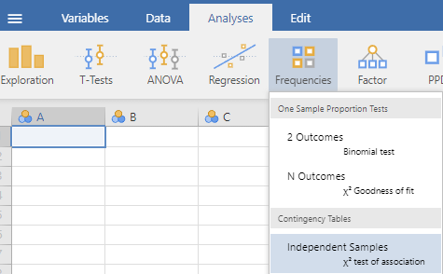
From the list of variables, move the independent variable, or the variable that is supposed to influence the dependent variable, into the Rows field, in this case the Treatment variable.
Next, the dependent variable, or one that is assumed to be influenced, is moved to the Columns field, in this case the Hyperglycemia variable.
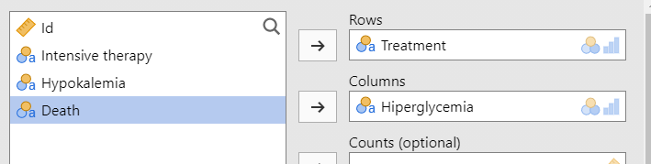
3. Observed contingency table
To display the observed contingency table, we make sure that in the Cells section, next to Counts, the Observed counts option is checked.

Copy the observed table in word.
4.-5. Percentages by rows
To display percentages by rows for the observed contingency table, we make sure that in the Cells section, the Row option is checked next to Percentages.
6. The difference in percentages
To display differences between the calculated frequencies by rows for the observed contingency table, we make sure that in the Statistics section, the Difference in proportions option is checked.

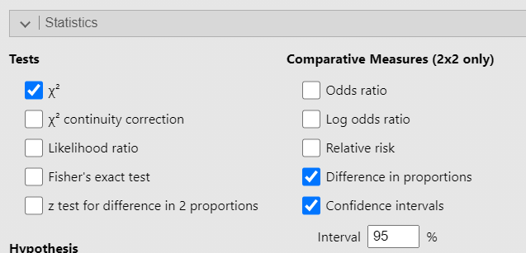
In this table it is observed that in the group that received methylprednisolone there were 72.6% subjects who had hyperglycemia, and in the group that received dexamethasone 38.57% had hyperglycemia. Thus, those who received methylprednisolone had hyperglycemia 34% more frequently than those who received dexamethasone.

7. Theoretical contingency table
To display the theoretical (expected) contingency table, we make sure that in the Cells section, the Expected counts option is checked. To see only the expected table, uncheck the Observed counts and the percentages.
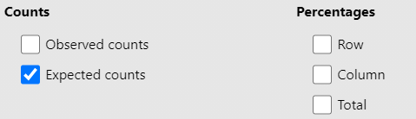
8. Chi-square or Fisher's exact test
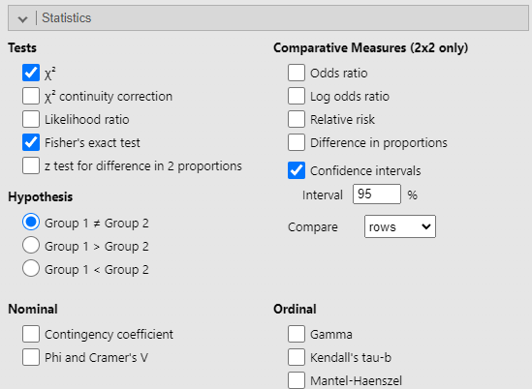
To select the statistical test of interest, in the Statistics section, next to Tests, you can choose various test variants: χ2 – the χ2 test; Fisher’s exact test – the Fisher exact test. Next to Hypothesis, leave the option Group 1 ≠ Group 2 (two-sided test).
Choosing the statistical test
We observe the 4 theoretical (expected) frequencies in the table, next to Expected: 39.2; 30.8; 40.8; 32.2. All four cells, i.e. 100% of the theoretical frequencies have values ​​over 5. Since over 80% of the cells in the theoretical table contain values ​​over 5, the χ2 test is used.
It is observed that the two variables are qualitative, their categories are mutually exclusive, we are not told in the statement that they would be dependent observations – so we deduce that they would be independent and all the cells in the content of the theoretical contingency table have values ​​greater than 5 (and none is 0), so the Chi-square test can be applied to these data.

9. Results interpretations. In word interpret the p value.
Choose one that apply in your case:
- If p<0.05, we reject the null hyphotesis H0, we are in favor of alternative hyphotesis H1: There is a statistically significant association between treatment with methylprednisolone / dexamethasone and hyperglycemia in subjects with COVID-19.
- If p≥0.05, we fail to reject the null hyphotesis H0, we are in favor of null hyphotesis H0: There is no statistically significant association between treatment with methylprednisolone / dexamethasone and hyperglycemia in subjects with COVID-19.
10. Chart
In the Plots section, check Bar plot; choose Stacked; choose Percentages, as well as within rows; choose Rows.
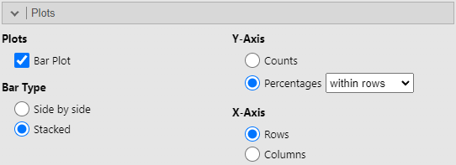
The results obtained will be copied to the Word file:
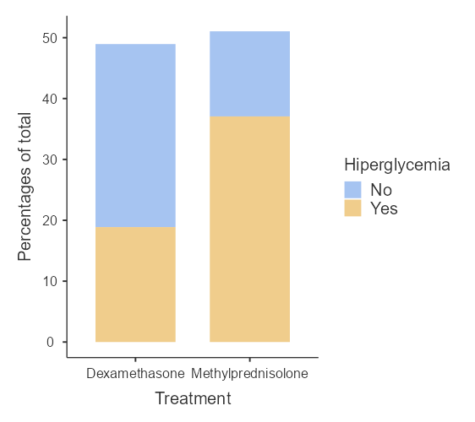
Requirement 2

Testing the association between treatment and deaths in Jamovi.
In the Analyses tab, Frequencies button, Contingency Tables menu section, select the Independent Samples χ2 test of association command.
From the list of variables, move the independent variable, or the variable that is assumed to influence the dependent variable, into the Rows field, in this case the Treatment variable. Then, move the dependent variable, or the variable that is assumed to be influenced, into the Columns field, in this case the Death variable.
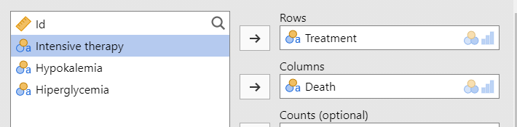

The same selections are made for the options as for the previous analysis, taking care to choose the correct statistical test (see below).
Choosing the statistical test
We observe the 4 theoretical (expected) frequencies in the table, next to Expected: 1.96; 68; 2.04; 71. Two of the cells, i.e. 50% of the theoretical frequencies have values ​​below 5. Since over 80% of the cells in the theoretical table contain values ​​below 5, the Fisher exact test is used.

The observed table, the percentages on the lines, the theoretical table, the p value for the Fisher exact test, the column graph, for testing the association between treatment and deaths, made in Jamovi are presented below:
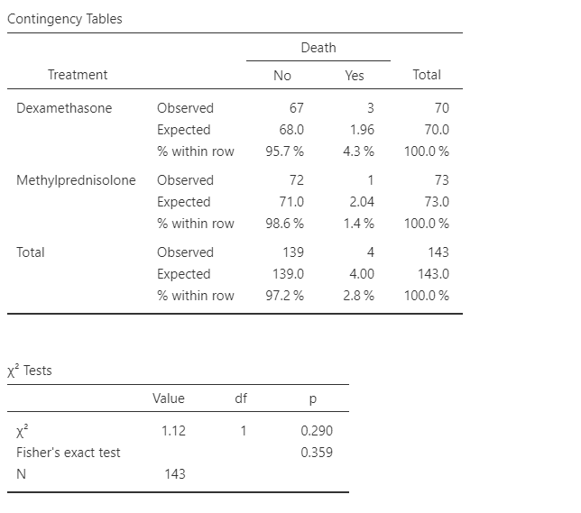

Plots
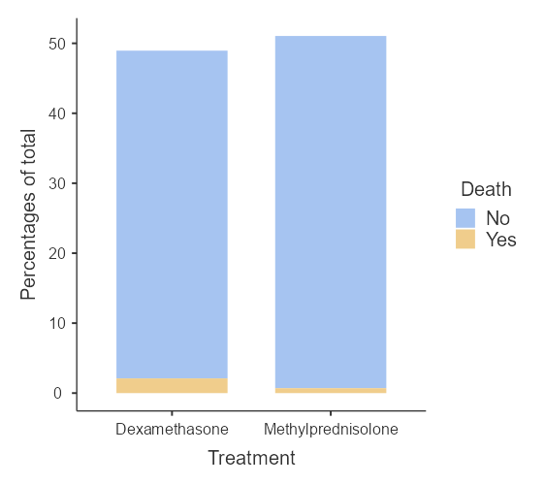

- The interpretation of these results will be transferred to the Word file:
- Null hypothesis: There is no statistically significant association between treatment and deaths in subjects with COVID-19, or there are no statistically significant differences between subjects with COVID-19 who received methylprednisolone and those who received dexamethasone, in terms of the frequency of deaths.
- Alternative hypothesis: There is a statistically significant association between treatment and deaths in subjects with COVID-19, or there are statistically significant differences between subjects with COVID-19 who received methylprednisolone and those who received dexamethasone, in terms of the frequency of deaths.
- Statistical significance level (alpha): 0.05
- P-value corresponding to Fisher's exact test: 0.359
- Interpret the test result based on the p-value: we cannot say that there is a statistically significant association between treatment and deaths in subjects with COVID-19, or we cannot say that there are statistically significant differences between subjects with COVID-19 who received methylprednisolone and those who received dexamethasone, in terms of the frequency of deaths.

- Interpretation of the graph
- In the image, it can be seen that in the group that received methylprednisolone there is a lower percentage of subjects with deaths (on the graph colored in blue), compared to those in the group that received dexamethasone. However, the differences between the two groups seem relatively small.

- Interpretation of the difference in percentages on the lines
- Looking at the percentage values ​​on the lines, it can be seen that in the group that received methylprednisolone there were 1.4% of subjects who died, and in the group that received dexamethasone 4.3% died. Thus, those who received methylprednisolone died 2.9% less often than those who received dexamethasone.

- Save the Word file.

REMEMBER!
- In the situation where we are interested in the association between two qualitative variables, with mutually exclusive categories, independent observations, and sufficiently high expected frequencies, one of the tests that we can use is the χ2 test or Fisher's exact test.

