Normal distribution
Make the histogram. Interpret the histogram.
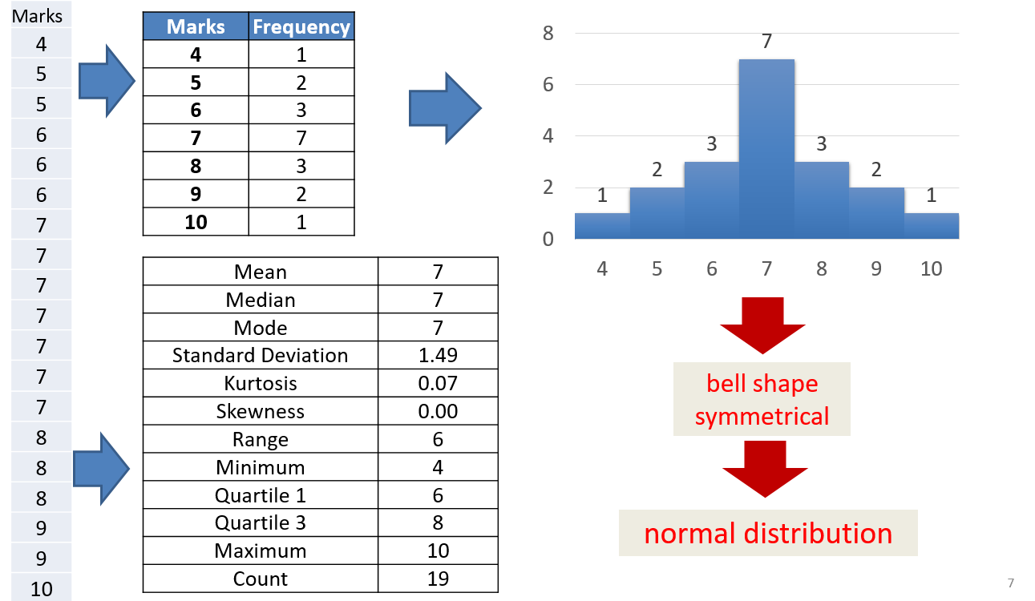

Calculate the descriptive statistics for the quantitative variable.
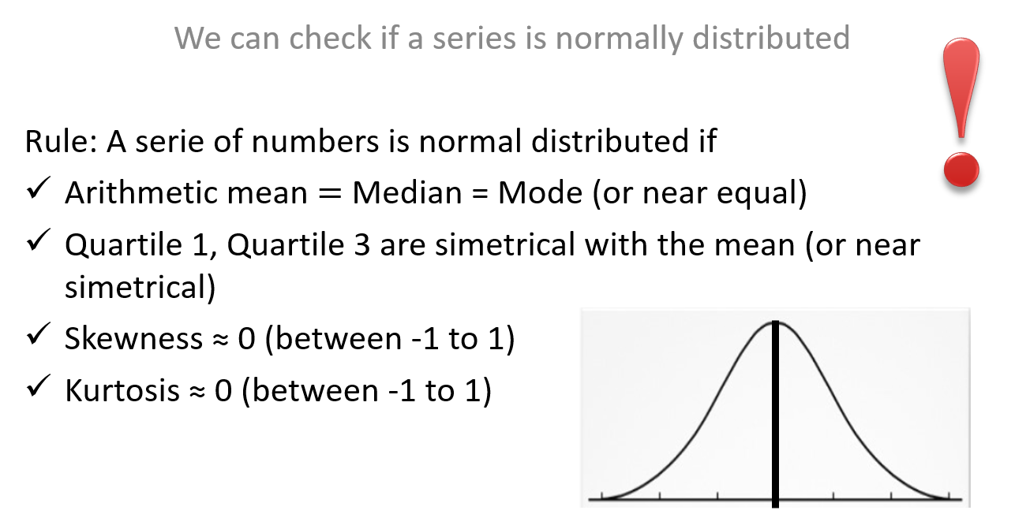
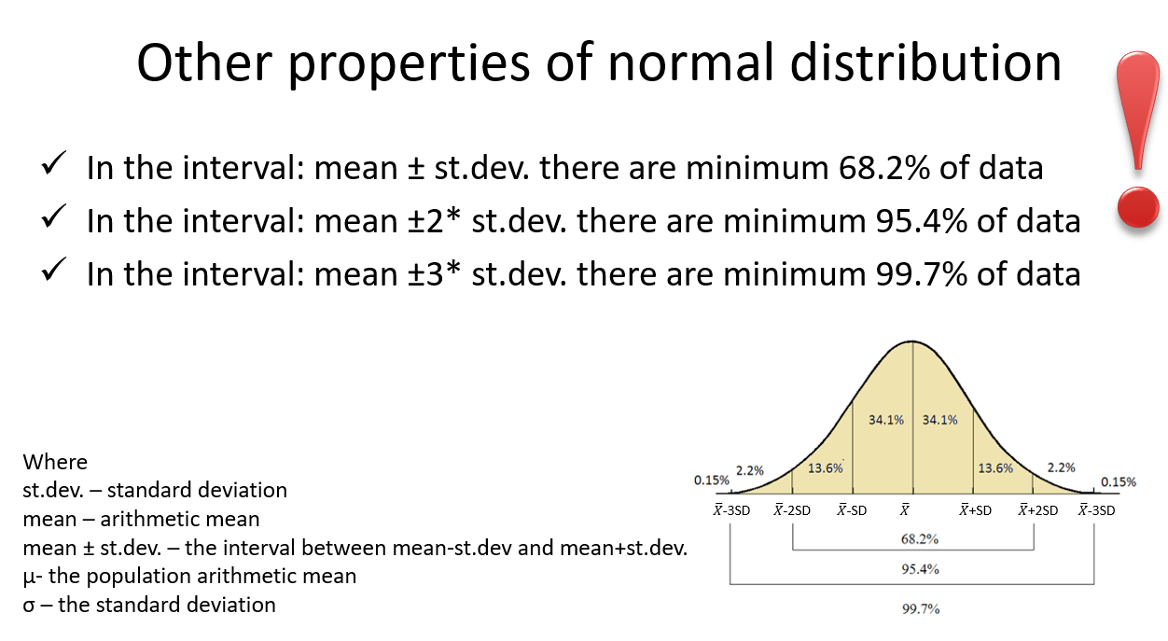

Estimate the population arithmetic mean with 95% confidence intervals
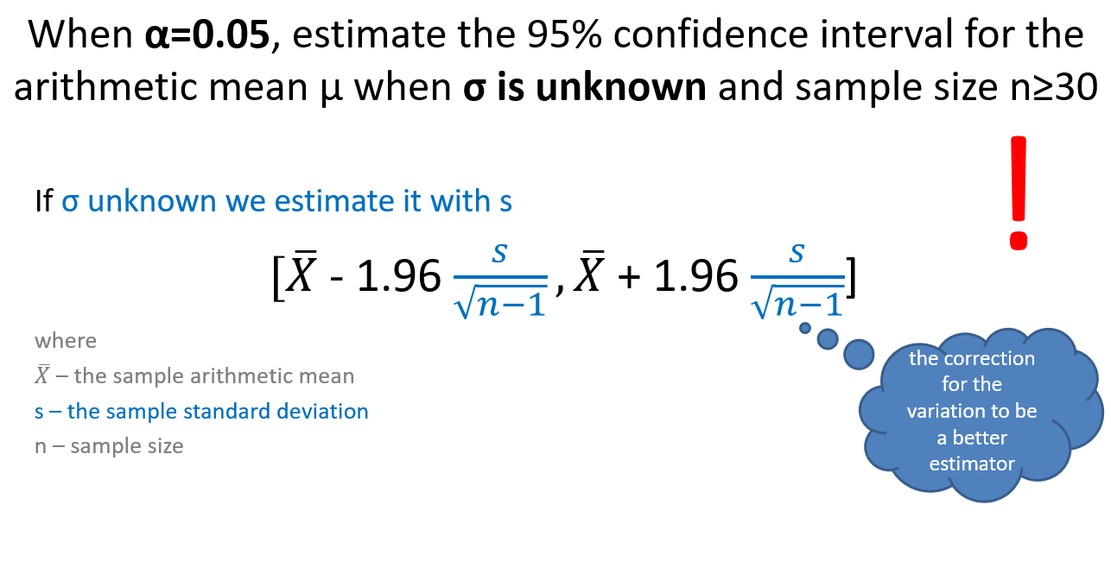
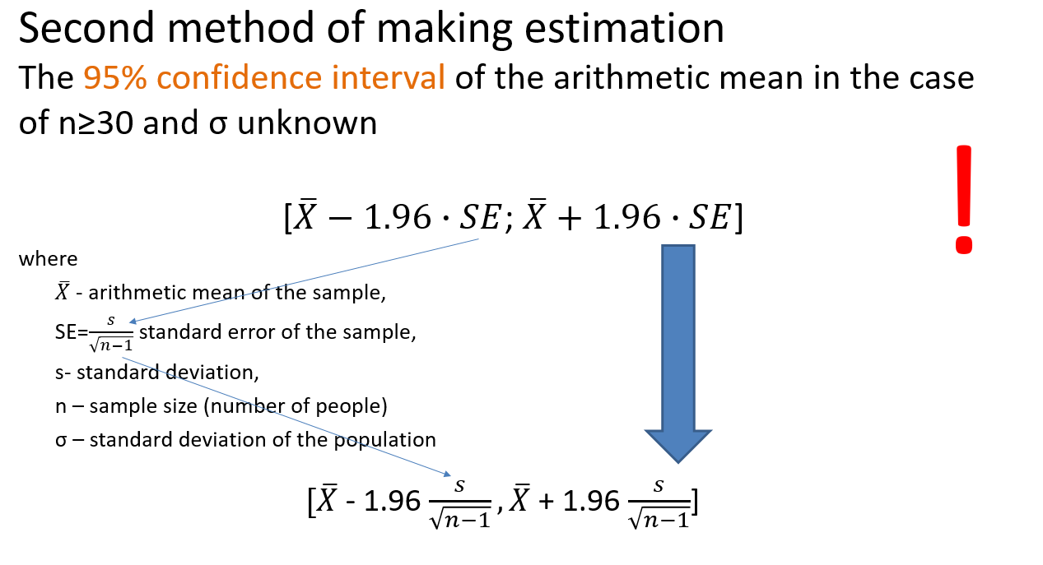
Interpretations of 95% confidence interval of an arithmetic mean
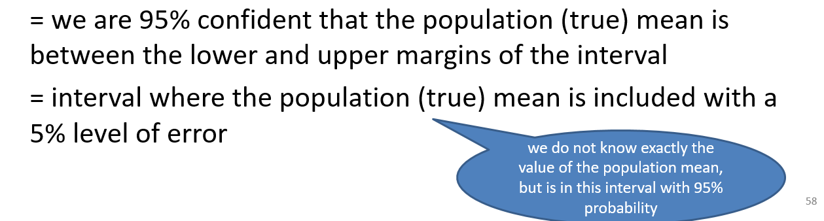

Estimate the population frequency with 95% confidence intervals

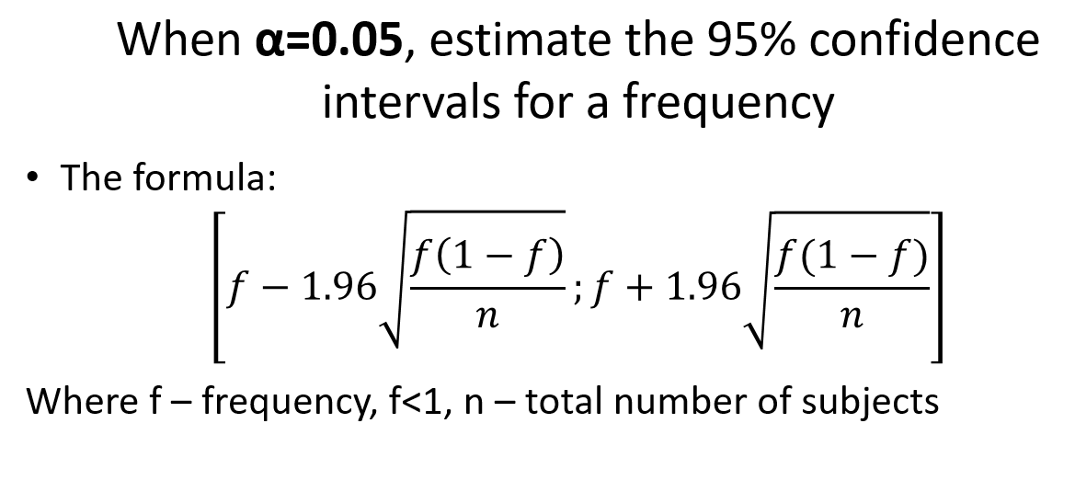
Interpretations of 95% confidence interval of a frequency



