Biostatistics & Medical Informatics ― Hints
Page1

Question (I1):
Step 1. Import the data in Jamovi application
Step 2. Verify the data type
Step 3. Filter the data to see only one sample (those who undergo GM)
Step 4. Calculate the statistical indicators
Step 5. Copy the indicators in PowerPoint
Step 6. Interpret normal distribution in PowePoint
Hints:
Step 1. IMPORTING A DATABASE INTO JAMOVI
Import the Excel file in Jamovi.
- Tap on the menu icon 
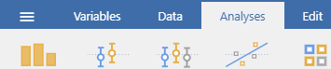
- Select the Open option
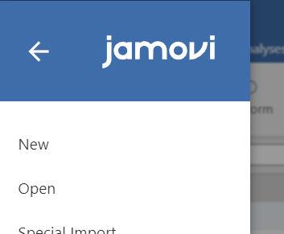
- Then, search for the folder containing the database by pressing the Browse button, select the desired file and press Open to import it.

Step 2. VERIFYING THE DATA TYPE IN JAMOVI
- Before starting the analysis, we must verify that the program has correctly classified the variables in the database. The Intervention Type variable is of qualitative type, and the BMI_Final variable is of quantitative type, etc.
- To verify the type of a variable, go in Data menu and double-click on the column title (variable name).
- In the case of quantitative variables, we make sure that the Continuous option is selected in the Measure type selection area. For qualitative variables, we make sure that the Nominal or Ordinal option is selected in the Measure type selection area, depending on the type of variable.
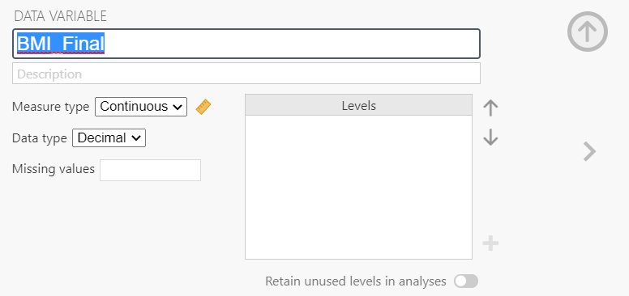

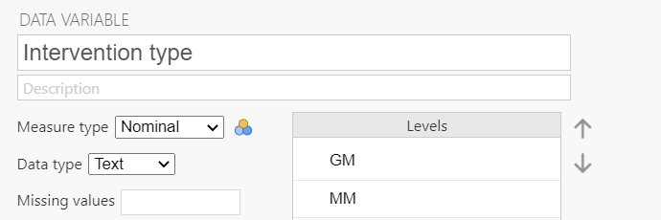
After you finish click on the arrow button from the upper left of the window.
Step 3. FILTER THE DATA IN JAMOVI
- Because we are only interested in the subgroup of patients who had the GM type intervention, we will filter the database according to this criterion
- In the DATA tab choose the FILTER option
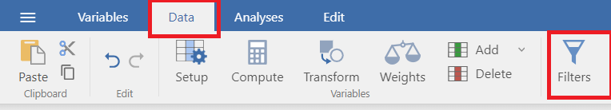
In the f_{x} line, we click on f_{x}, choose Intervention type from the variable list then type ==’GM’ to write the syntax:
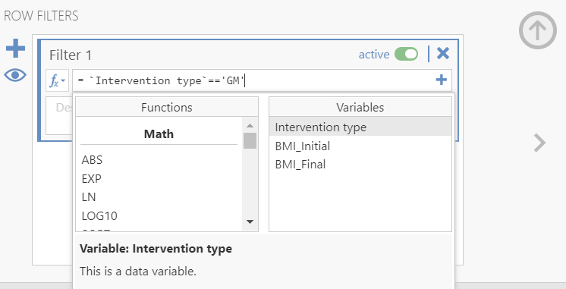
Validate the syntax with the arrow button.
This will result in the temporary deletion of the other group (those treated with MM) from the database:
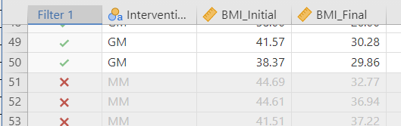

Step 4. Calculate descriptive statististics in Jamovi
Go to Analysis tab. Choose Exploration. Descriptive statistics
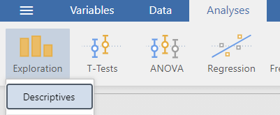
Move BMI_final to variables. Choose to calculate N, Mean, Median, Mode, Percentiles, Skewness, Kurtosis
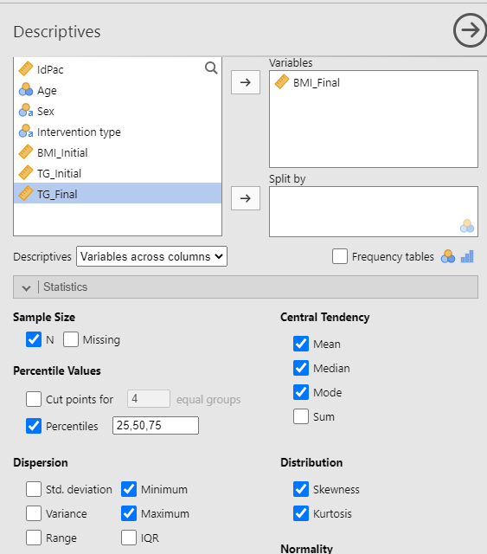
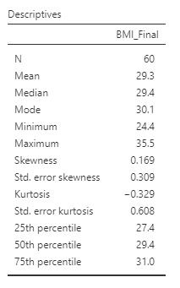
Step 5. Copy the indicators in PowerPoint slide 3
You find Table-Copy option at right click on the table with the results.
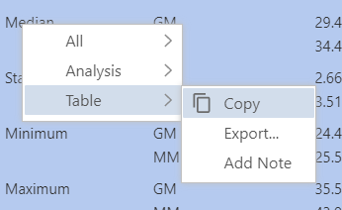

Step 6. Interpret normal distribution in PowerPoint
Respond to the question
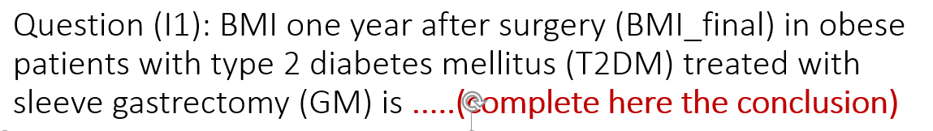
Question (I2):
Repeat the above steps to responde to this question on slide 4.
Question (I3):
Step 1. Remove the Filter
Step 2. Choose the statistical test
Step 3. Formulate the hyphotesis
Step 4. Calculate the test p-value
Step 5. Copy the test results in PowerPoint
Step 6. Interpret the results in PowerPoint. Give the conclusion.
Step 1. Remove the Filter
Deactivate or click on ”x” button
Step 2. Formulate the hyphotesis (complete the PowerPoint slide 5):
Hyphotesis formulation
Null hyphotesis (H0) | There is no statistically significant difference between the mean BMI one year after surgery in obese patients with T2DM who undergo GM and those who undergo MM gastroplasty
Alternative hyphotesis (H1) | There is statistically significant difference between the mean BMI one year after surgery in obese patients with T2DM who undergo GM and those who undergo MM gastroplasty

Step 3. Choose the statistical test
Choosing the appropriate statistical test to compare the arithmetic means of a quantitative variable across two populations (see the table below):
Wich are the samples type? | How is the distribution type? | How are the variances? | This is the test you need to apply
Independent | Normal probability distribution | without statistically signifcant difference (equal) | Student's t-test with equal variances
Independent | Normal probability distribution | with statistically signifcant difference (unequal) | Student's t-test with unequal variances (Welch’s test)
Independent | Non-normal probability distribution | - | Mann-Whitney U test
Dependent | Normal probability distribution | - | Student's t-test on dependent samples (Paired t-test)
Dependent | Non-normal probability distribution | - | Wilcoxon rank test
Complete the PowerPoint slide 6 with the statistical test

Step 4. STUDENT test on two INDEPENDENT samples for equal variances in Jamovi
In the Analyses tab, click on the T-Tests button, then select the Independent Samples T-Test option from the menu.
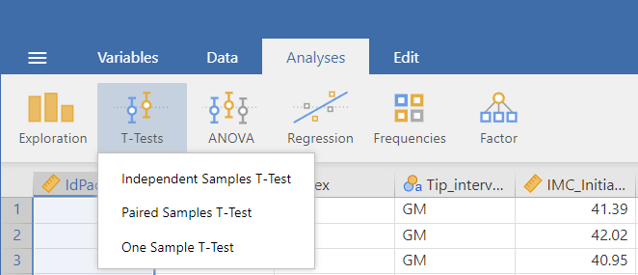
- To compare the effectiveness of the two surgical techniques, we need to group the data according to the type of intervention. So, select the variable Type_of_intervention and press the arrow button next to the Grouping Variable field.
- Then, because we want to compare the BMI-Final values ​​between the two groups, select the variable BMI_Final and press the arrow button next to the Dependent variables field.
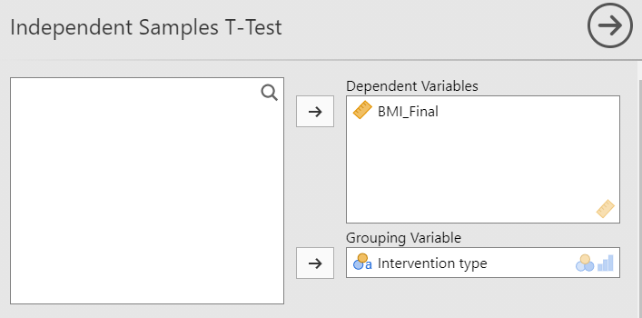
- Also, in the Tests section, choose the options: Student’s (Student’s test with equal variances) and Descriptives.
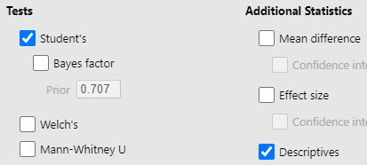
Step 5. Copy the test results in PowerPoint on slide 6
- The results and descriptive statistics will be in the right part of the screen
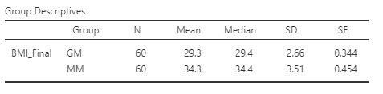
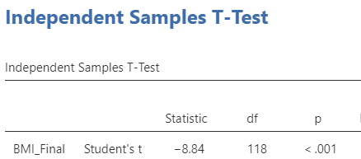

Step 6. Interpret the results in PowerPoint on slide 7. Give the conclusion.
Interpretation of the STUDENT test result on independent samples:

Because the p-value of the test < 0.05 ⇨ we reject H0 ⇨ we are in favor of H1 ⇨ With a 5% risk of error, there is a statistically significant difference between the BMI averages one year after surgery in obese T2DM patients treated with GM and those treated with MM.
Results
p-value | <0.001
Interpretations
Test decision based on p-value | p < 0.05, we reject null hyphotesis H0, we are in favor of the alternative hyphotesis H1: With a 5% risk of error, there is a statistically significant difference between the BMI averages one year after surgery in obese T2DM patients treated with GM and those treated with MM.

Question (I4):

Step 1. Formulate the hyphotesis for Shapiro-Wilk test for normality (complete the PowerPoint slide 8):
Null hypothesis (H0): The data follow a normal distribution in patients treated with GM.
Alternative hypothesis (H1): The data do NOT follow a normal distribution in patients treated with GM.
Step 2. Filter the data:
- Because we are only interested in the subgroup of patients who had the GM type intervention, we will filter the database according to this criterion.
In the f_{x} line, we click on f_{x}, choose Intervention type from the variable list then type ==’GM’
This will result in the temporary deletion of the other group (those treated with MM)
Step 3. Test for the normality of a distribution in JAMOVI with a statistical test
- In the Analyses menu, the EXPLORATION tab → Descriptives option will be used
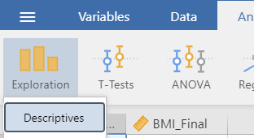
- Select both BMI_initial and BMI_final.
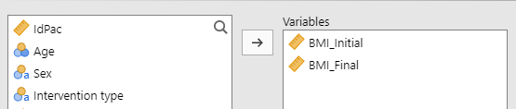
- Select in the Statistics tab → Normality Shapiro-Wilk test
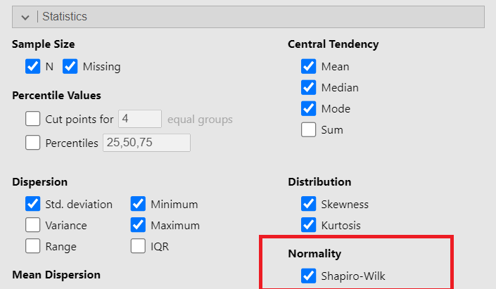
- The result will be of the following form:
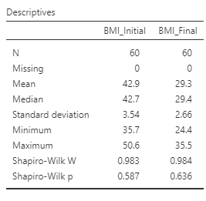
Step 3. Interpret the results in PowerPoint on slide 9. Give the conclusion.
Shapiro-wilk test for normal distribution interpretation:

Because the p-value of the test for BMI_initial in patients treated with GM was p =0.587> 0.05 ⇨ We fail to reject H0 ⇨ We do not have enough evidence to say that the BMI_initial do not have a normal distribution in patients treated with GM.

Question (I5):
Step 1. Formulate the Hyphothesis
In PowerPoint, slide 10
Step 2. Choose the statistical test
Choosing the appropriate statistical test to compare the arithmetic means of a quantitative variable across two populations (see the table below):
Wich are the samples type? | How is the distribution type? | How are the variances? | This is the test you need to apply
Independent | Normal probability distribution | without statistically signifcant difference (equal) | Student's t-test with equal variances
Independent | Normal probability distribution | with statistically signifcant difference (unequal) | Student's t-test with unequal variances (Welch’s test)
Independent | Non-normal probability distribution | - | Mann-Whitney U test
Dependent | Normal probability distribution | - | Student's t-test on dependent samples (Paired t-test)
Dependent | Non-normal probability distribution | - | Wilcoxon rank test
Complete the PowerPoint slide 11 with the name of the statistical test
Step 3. STUDENT test on two DEPENDENT samples in JAMOVI
- In the ANALYSES tab, click the T-Tests button, then select the Paired Samples T-Test option from the menu.
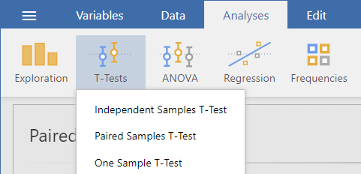
- Select the variable BMI_Initial and press the arrow button next to the Paired Variables field. Then, select the variable BMI_Final and press the arrow button next to the Paired Variables field.
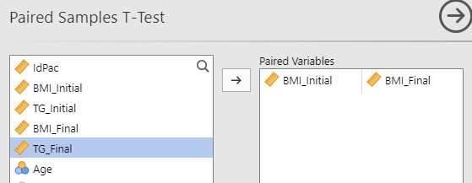
- Options: Student’s and Descriptives.
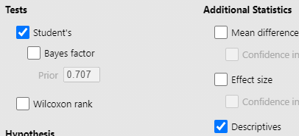
Step 4. Copy the test results and the descriptive statistics in PowerPoint on slide 11
- The program will generate a table with the results of the t-Student test on the right.
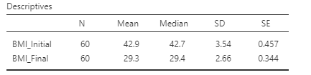
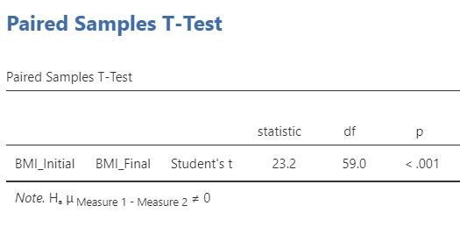
Step 5. Interpret the results in PowerPoint on slide 12. Give the conclusion.
Interpretation of the paired Student's test:
Because the p-value (<0.001) <0.05 ⇨ we reject H0 ⇨ we favor H1 ⇨ At the 5% risk, there is a significant difference between the BMI means before and one year after surgery in obese patients with T2DM treated with GM.
Question (I6) and (I7)
Step 1. Formulate the hyphotesis for Shapiro-wilk test for normal distribution complete the PowerPoint slide 13
Step 2. Test a distribution for normality in JAMOVI with a statistical test
- In the Analyses menu, the EXPLORATION tab → Descriptives option will be used
- Select TG_ final, move it to the Variables section. Select Intervention type, move it to the Split by section.
- Select in the Statistics tab → Normality Shapiro-Wilk test
- The result will be of the following form:
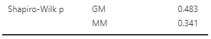
Step 3. Interpret the results in PowerPoint on slide 14. Give the conclusion.

Question (I8):
Step 1. Formulate the Hyphothesis
In PowerPoint, slide 15
Step 2. The Levene test for variances in Jamovi
To test two variances in the Analyses tab, click on the T-Tests button, then select the Independent Samples T-Test option from the menu.
- Because we want to compare the variances of TG_Final ​​between the two groups, select the variable TG_Final and move it to the Dependent variables field.
- To compare two groups move type of intervention to the Grouping Variable field.
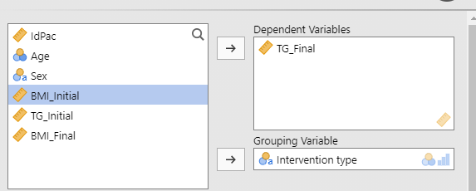
- In the Assumptions Checks section, choose the Homogeneity test option which will result in a variance test.
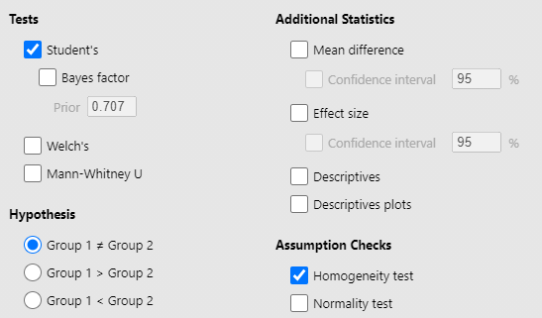
- The variance test (Levene’s test) result.
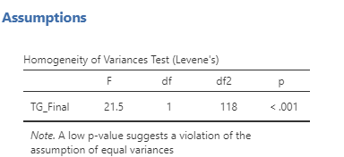
Step 3. Interpretation of the LEVENE test result on independent samples. Complete the PowerPoint presentation slide 16.
- Because the p-value of the test <0.001< 0.05 ⇨ We reject H0 ⇨ With a 5% risk of error, we find a statistically significant difference between the TG variances one year after surgery in obese T2DM patients treated with GM and those treated with MM.

Question (I7):
Step 1. Formulate the hyphotesis (complete the PowerPoint slide 17)
Step 2. Choose the statistical test
Choosing the appropriate statistical test to compare the arithmetic means of a quantitative variable across two populations (see the table below):
Wich are the samples type? | How is the distribution type? | How are the variances? | This is the test you need to apply
Independent | Normal probability distribution | without statistically signifcant difference (equal) | Student's t-test with equal variances
Independent | Normal probability distribution | with statistically signifcant difference (unequal) | Student's t-test with unequal variances (Welch’s test)
Independent | Non-normal probability distribution | - | Mann-Whitney U test
Dependent | Normal probability distribution | - | Student's t-test on dependent samples (Paired t-test)
Dependent | Non-normal probability distribution | - | Wilcoxon rank test
Write the name of the test in PowerPoint Slide 18.

Step 3. Make the test in Jamovi application
In the Analyses tab, click on the T-Tests button, then select the Independent Samples T-Test option from the menu.
- Choose the variables.
- In the Tests section, choose the option: Student’s for Student’s test with equal variances or Welch’s test for Student’s test with unequal variances or Mann-Whitney U
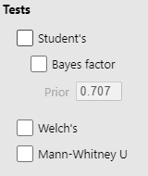
- The results will be in the right part of the screen
- Step 3. Interpretation of the test result on independent samples. Complete the PowerPoint presentation slide 18-19.

