Formulas
Probability of an event
Let A = {birth of a male child}
Probability of the event A is:
P(A) = (number of favorable cases)/(number of possible cases)
where number of favorable cases is given by those who accomplished the required criterion (e.g. birth of a male child).
Probability of nonA
The probability that something happens is one minus the probability that it does not:
P(A) = 1 - P(nonA)
Compose event: Reunion
P(A sau B)=P(A$∪$B)
P(A$∪$B) = P(A) $+$P(B) - P(A$∩$B)
where A and B are any two events.
Compose event: Intersection
Independent events
If two events A and B are independent: P(A$∩$B) = P(A) $∙$ P(B).
Probabilities applications
1. Prevalence = probability that a subject to have Alzheimer. Use the data from GoldenTest column to answer this question
2. Sensibility (Se = P(T|A)) = probability that a test result will be positive when the Alzheimer is present. The following events are used in this formula: T = {Alzheimer test positive} and A = {Alzheimer positive = Golden test positive}
3. Specificity (Sp = P(nonT|nonA)) = probability that a test result will be negative when the Alzheimer is not present
4. Positive predictive value (PPV = P(A|T)) = probability that the Alzheimer is present when the test is positive.
5. Negative predictive value (NPV = P(non A|nonT)): probability that the Alzheimer is not present when the test is negative.
Relationship between a risk factor and a disease
Disease  / Risk factor | B  With illness | non(B)  Without illness | Total
Risk factor +  A | a | b | a+b
Risk factor –  non A | c | d | c+d
Total | a+c | b+d | n

Relative risk
$RR=\frac{P\left(B | A\right)}{P\left(B | \overline{A}\right)}$ = $\frac{P\left(Disease | Risk factor\right)}{P\left(Disease | \overline{Risk factor}\right)}= \frac{\frac{a}{a+b}}{\frac{c}{c+d}}$
Risk difference
RD = 𝑃(𝐷𝑖𝑠𝑒𝑎𝑠𝑒│𝑅𝑖𝑠𝑘 𝑓𝑎𝑐𝑡𝑜𝑟) - 𝑃(𝐷𝑖𝑠𝑒𝑎𝑠𝑒│(𝑅𝑖𝑠𝑘 𝑓𝑎𝑐𝑡𝑜𝑟) ̅ )
=𝑎/(𝑎+𝑏) − 𝑐/(𝑐+𝑑)
2. 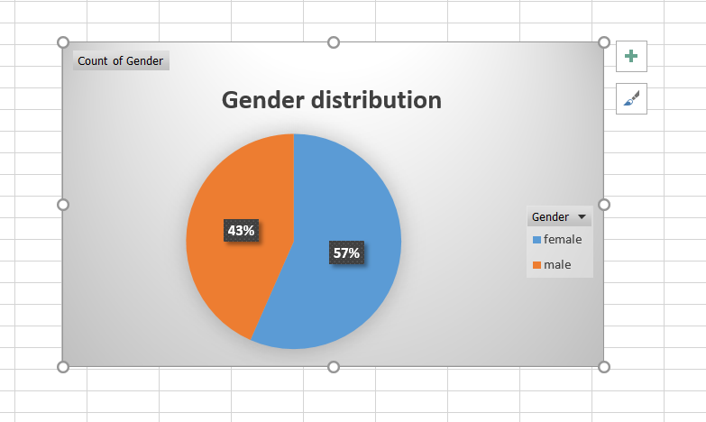

3. Working with contingency tables in Excel
• Select one cell of the table with data (e.g. A2)➔ the whole database it will be selected.
• [Insert-PivotTable]. The next window will appear:
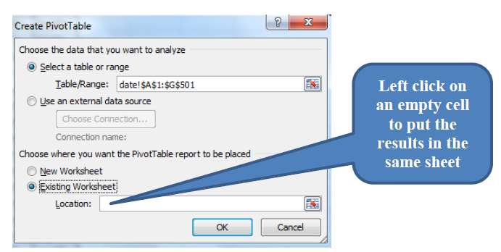
• Left click on an empty cell to put the results in the same sheet
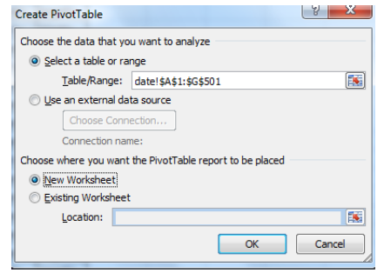
• Validate with OK.
• Using drag-and-drop option place GoldenStandard on Column and Test1 on Row Label. Drag-and-drop again the GoldenTest on Value. The resulted selection is similar with the one in the image bellow:
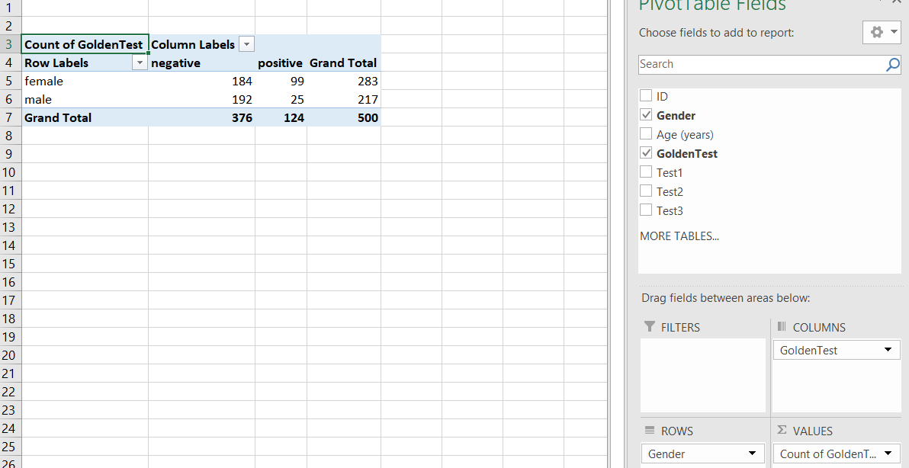
!!! Check if the total is equal with the sample size!!!!
o Use sort option to have in the first column the positive values:
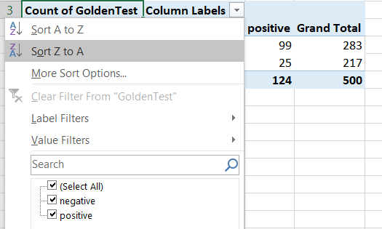
o Copy the contingency table in empty cells and change it to look as the one in the image bellow:
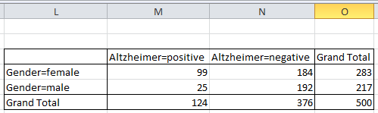
4. 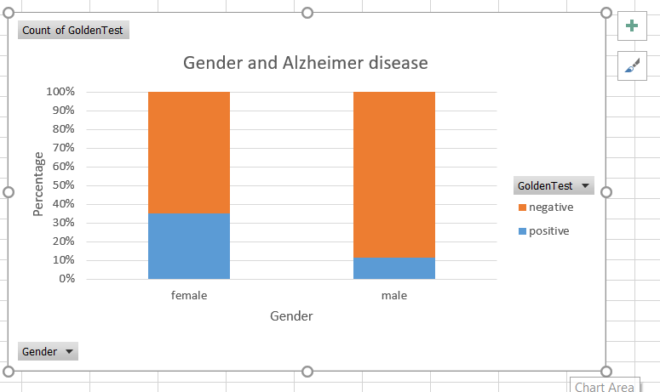
7.
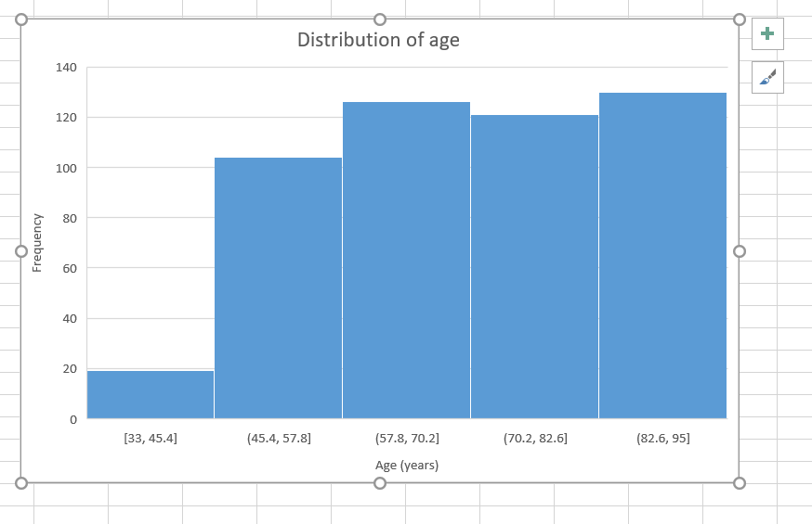
8.


