Quantitative variables: descriptive statistics parameters & graphical representation
SOLUTIONS
2. Use the predefined functions or formulas below:
Centrality measurements Functions Formulas
Arithmetic mean | =AVERAGE(ARRAY)
Median | =MEDIAN(ARRAY)
Mode | =MODE.MULT(ARRAY)  =MODE.SINGL(ARRAY)
Central value |  | =(MAX(ARRAY)+MIN(ARRAY))/2
Dispersion
Range |  | =MAX(ARRAY)-MIN(ARRAY)
Variation | =VAR.S(ARRAY)
Standard deviation | =STDEV.S(ARRAY)  =SQRT(VAR.S(ARRAY))
Standard error |  | =STDEV.S(ARRAY)/SQRT(COUNT(ARRAY))
Coeficient of variation |  | CV =STDEV.S(ARRAY)/AVERAGE(ARRAY)  CQV =(QUARTILE.INC(ARRAY,3)-QUARTILE.INC(ARRAY,1))/(QUARTILE.INC(ARRAY,3)+QUARTILE.INC(ARRAY,1))
Locality
Minimum | =MIN(ARRAY)  =QUARTILE.INC(ARRAY,0)
Quartile 1 | =QUARTILE.INC(ARRAY,1)
Quartile 2 = MEDIAN | =QUARTILE.INC(ARRAY,2)  =MEDIAN(ARRAY)
Quartile 3 | =QUARTILE.INC(ARRAY,3)
Maximum | =MAX(ARRAY)  =QUARTILE.INC(ARRAY,4)
Percentila (ex.80%) | =PERCENTILE.INC(ARRAY,0.8)
Asymmetry
Asymmetry | =SKEW(ARRAY)
Kurtosis | =KURT(ARRAY)
where ARRAY is the selection of cells containing the values ​​of the variable of interest.

Indications:
- Select the cell where you want to get the result before choosing the predefined function.
- To use predefined functions: A. Home – Function (fx) or
B. Formulas → Insert Function

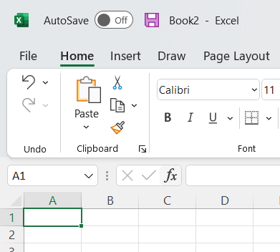
A.
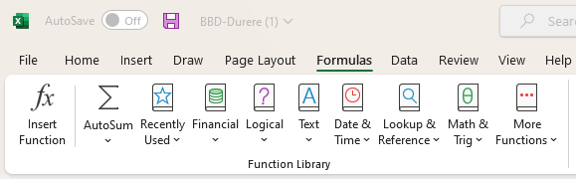
B.

- Choose the All category. In this category you will be able to find all the predefined functions you need.

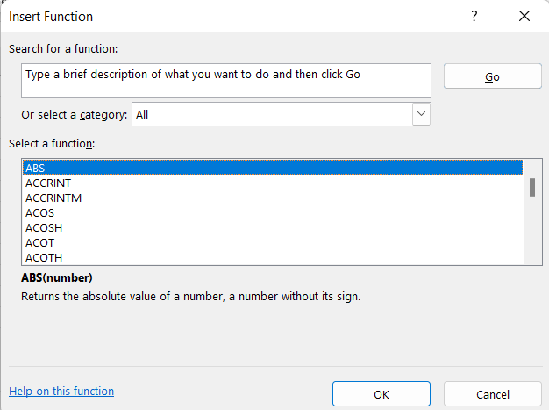

- From the "Select a function" window, select the desired function. Select, for example, the AVERAGE function that allows calculating the arithmetic mean.

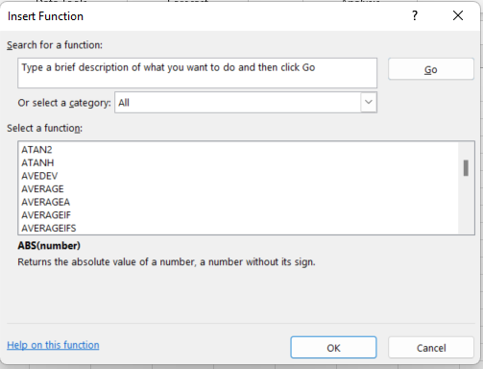
- In the cell corresponding to `Number 1`, select the relative references of the cells for the variable of interest. Validate with OK to obtain the average value.

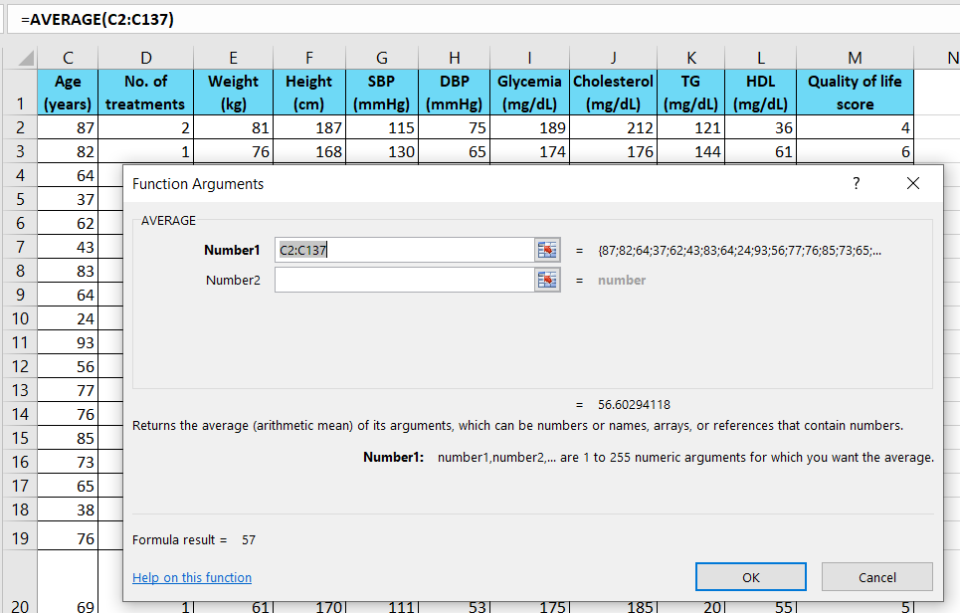

4. Histogram of the entire group
In the spreadsheet, named "Histogram", make the following requirements:
❖ Select the Cholesterol (mg/dL) in the data table and insert a Histogram type graph from the Insert→ Chart→ Histogram menu.
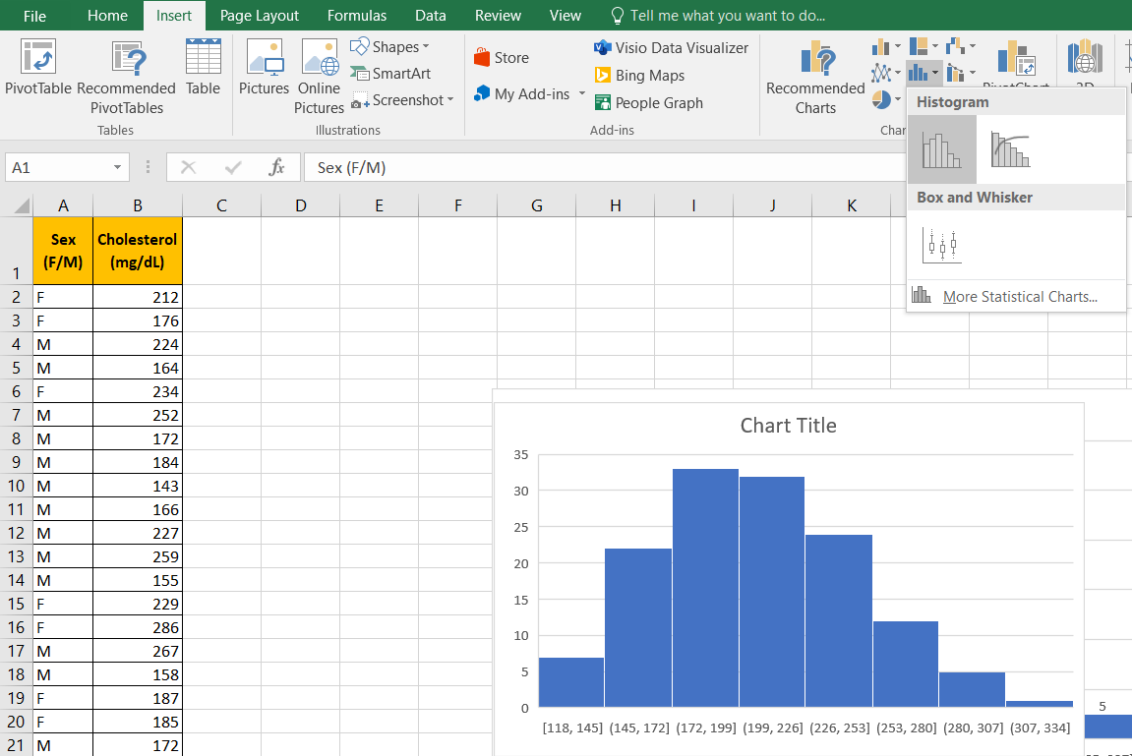
❖ Add the absolute frequencies to the columns using the + button in the upper right corner by checking Data labels.
❖ Add axis titles using the + button in the upper right corner by checking Axis Titles.
❖ Enter the headings from the requirements on each individual axis.
❖ Change the number of column from + button – Axis options – Number of bins
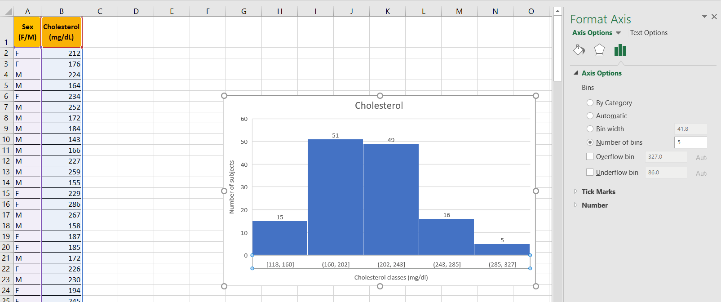
❖ At the end the graph should look like the one below:
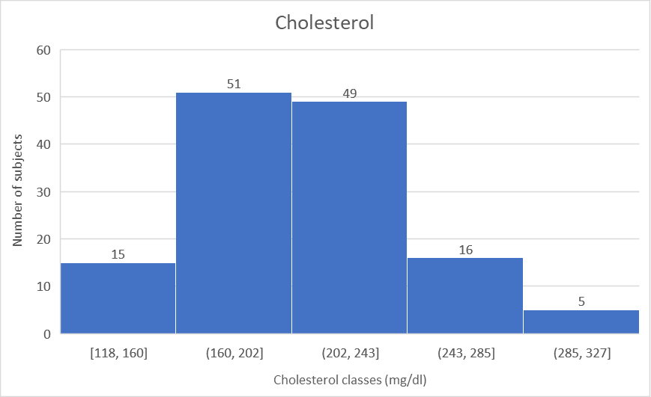

- Scatter chart

In the spreadsheet, named "Scatter" make the following requirements:
❖ Select both the Weight and Cholesterol data columns from the data table and insert a Scatter plot from the Insert→Chart→Scatter menu.
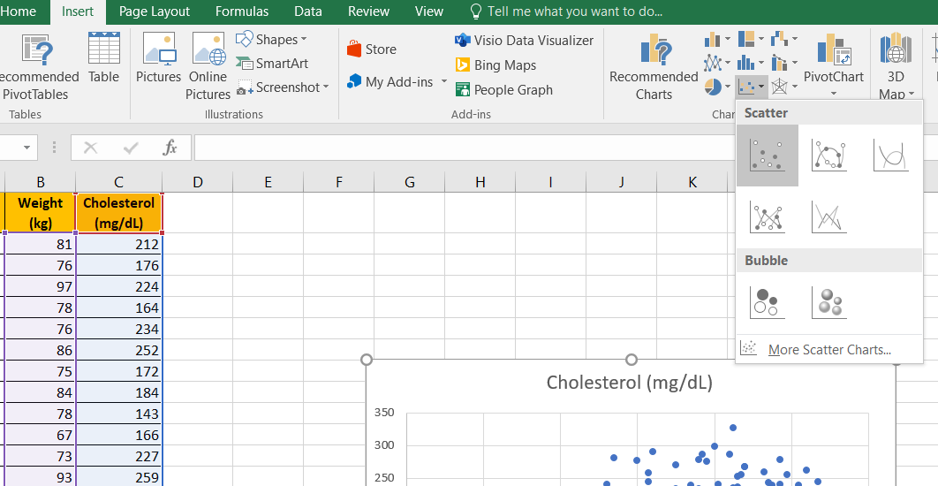

❖ Add axis titles using the + button in the upper right corner by checking Axis Titles. Enter the headings from the requirements on each individual axis.
❖ To change the values ​​for the horizontal/vertical axis, right-click on the horizontal axis values ​​and select Format Axis:
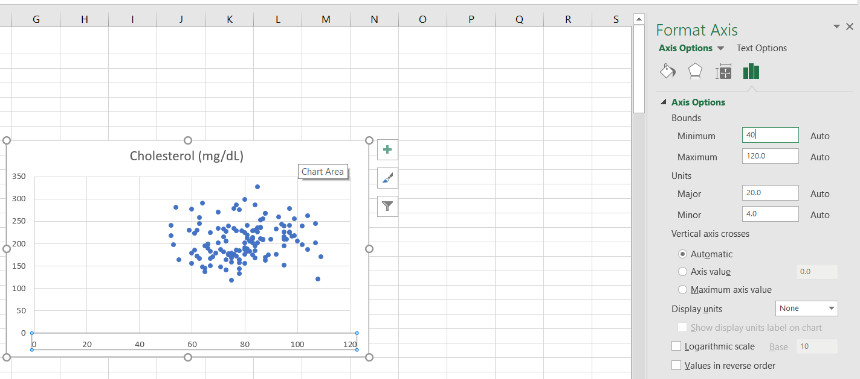

❖ At the end the graph should look like the one below:

6. Box – whiskers plot
In the spreadsheet named "Box - whiskers" make the following requirements:
❖ Select the two columns: the first column must be the one containing the grouping variable (Sex) and the second column must be the one containing the qualitative ordinal (over 5 categories) or quantitative variable (Cholesterol).
❖ Select the headings of the two Sex and Cholesterol columns in the data table and insert a Box and Whisker chart from the Insert → Chart → Box and Whisker menu.
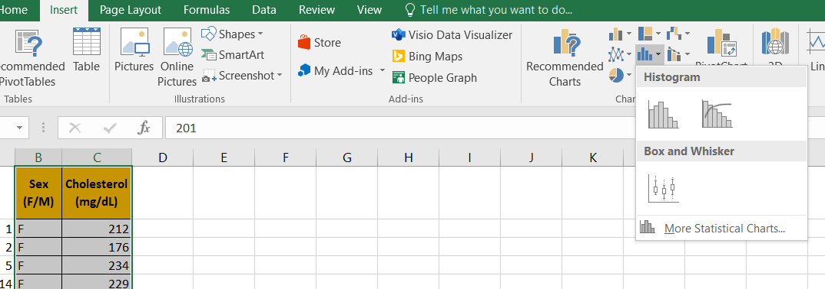

❖ Add the absolute frequencies using the + button in the upper right corner by checking Data labels.
❖ Add axis titles using the + button in the upper right corner by checking Axis Titles.
❖ Enter the headings from the requirements on each individual axis.
❖ At the end the graph should look like the one below:
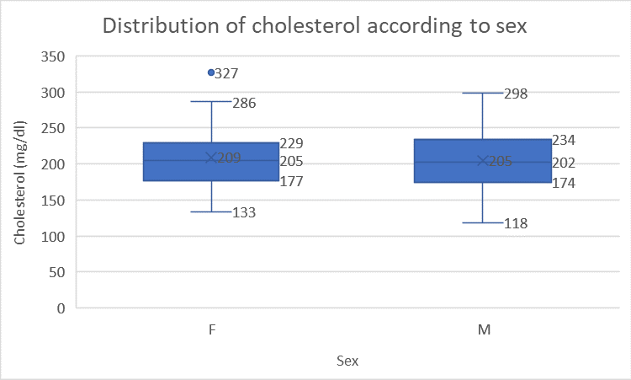

7. Histograms for female and male patients
In the spreadsheet called "Histogram" make the following requirements:
❖ Sort data by Sex: Select column title Sex (F/M) → Home→ Sort & Filter→ Expand the selection→ Custom sort→ Sort by→ Sex(F/M).
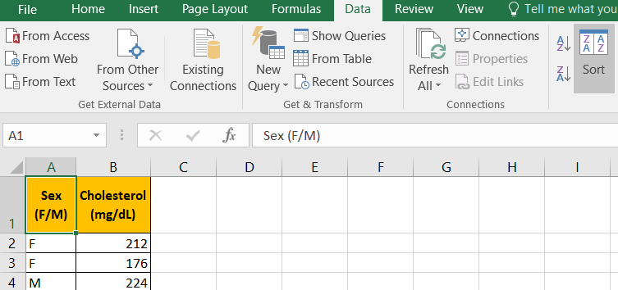
❖ Finally the chart for female patients should look like:
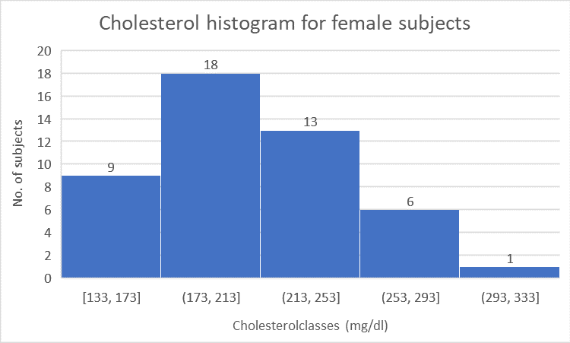
❖ Finally the graph for male patients should look like this:
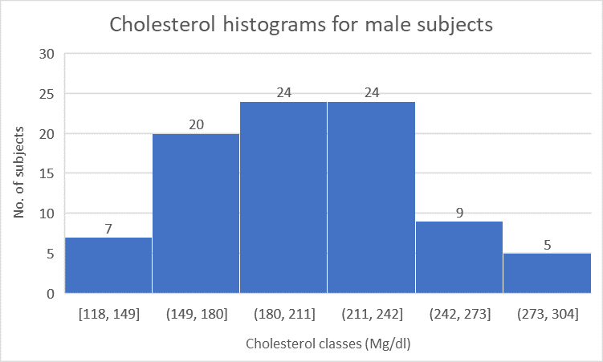

9. Statistical indicators separately for women and men.
In the spreadsheet named "Subgroups" complete the following requirements:
❖ Sort data by Sex: Home → Sort & Filter → Expand the selection → Custom sort → Sort by → Sex (F/M).


