SOLUTIONS
2. and 3. Use the predefine function in the case of following parameters:
Parameter | Perceived Stress Scale
Centrality
Median | MEDIAN function or QUARTILE function opr QUARTILE.INC function
Mode | MODE function or MODE.SNGL function or MODE.MULT function
Localization
Minimum | MINIMUM function or QUARTILE function or QUARTILE.INC function
First quartile | QUARTILE function QUARTILE function or QUARTILE.INC function
Third quartile | QUARTILE function QUARTILE function or QUARTILE.INC function
Maximum | MAXIMUM function or QUARTILE function QUARTILE.INC function
Dispersion
Range
Interquartile range

Sintax for MEDIAN function:
=MEDIAN(range)
Where range is the range of cell of the interest variable. Ex. For the Perceived Stress Scale =MEDIAN(G2:G101)
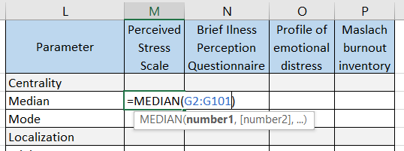
Sintax for MODE, MINIMUM and MAXIMUM function:
=MODE(range)
=MIN(range)
=MAX(range)
Where range is the range of cell of the interest variable.
Sintax for QUARTILE function:
=QUARTILE(array,quartile)
Where array is the range of cell of the interest variable and quartile is a number from 0 to 4 that correspond to the number of the quartile. Ex. For the First quartile of the Perceived Stress Scale =Quartile(G2:G101,1)
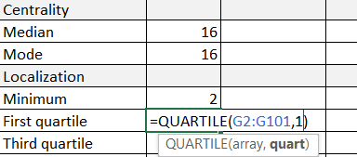
! QUARTILE.INC function return the same numbers ad Quartile function and have the same arguments.
4. Use the following formula to calculate Range and Intercuartile range:
Range=Maximum-Minimum
Ex. In case of the Perceived Stress Scale variable: =MAX(G2:G101)-MIN(G2:G101)
Use the following formula to calculate Intercuartile range:
Intercuartile range=First quartile-Third quartile
Ex. In case of the Perceived Stress Scale variable: =QUARTILE.INC(G2:G101,3)-QUARTILE.INC(G2:G101,1)
5. Use the following as an example of interpretation of the requested descriptive statistics parameters:
Parameter | Brief Illness Perception Questionnaire (n=100) | Interpretation
Minimum | 0 | 100% of the scores were higher or equal than 0
First quartile | 27.5 | 25% of the scores were smaller or equal than 27.5
Median | 33 | 50% of the scores were smaller or equal than 33 and 50% were higher or equal
Third quartile | 40.25 | 75% of the scores were smaller than 40.25
Maximum | 61 | All the scores were smaller or equal than 61
6. Select the reqested variable. Insert the Box-Whiskers plot from the Insert Menu.
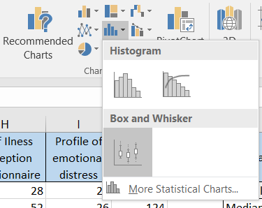

7.
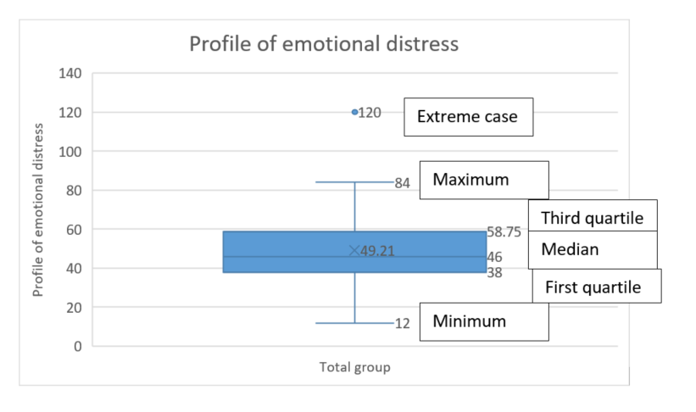
Complete the table according to the chart before.
8. Copy both variables on another sheet in Excel, first gender (the grouping variable), second the Perceived Stress Scale.
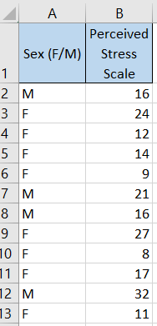
Select both comlumns. Insert the Box-Whiskers plot from the Insert Menu.

9. Copy both variables on another sheet in Excel, first the profession (the grouping variable), second the Brief Ilness Perception Questionnaire.
Select both columns. Insert the Box-Whiskers plot from the Insert Menu.

10. Copy the School variable and Profile of emotional distress and Maslach burnout inventory variables on another sheet in Excel, first the School (the grouping variable), second the Profile of emotional distress and third the Maslach burnout inventory.
Select all three columns. Insert the Box-Whiskers plot from the Insert Menu.

11. Sort the data from the Sheet1 by the Age. Data Menu, Sort
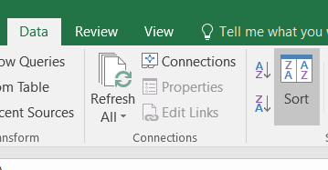
Choose Age at Sort by and check My data has headers.
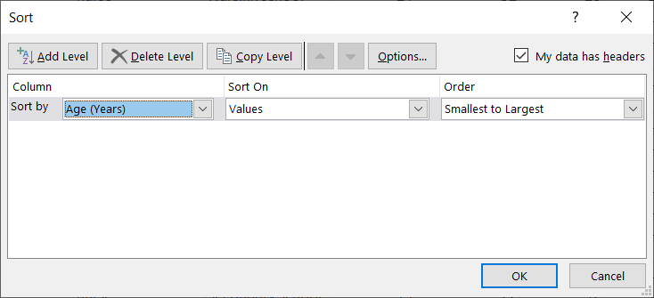
!!! All the data should change the order, not only the age.
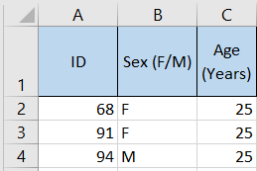
Complete the category for the first patient. Than filled down, than etc.
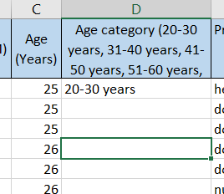

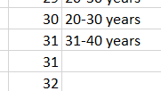
After you finish, sort again the data by ID, than your data will be in the same order it was when we start the analysis.

ONLINE EDUCATIONAL RESOURCES
Videos on the Microsoft page: https://support.microsoft.com/ro-ro/excel
How to use PivotTable in Excel
How it is created a chart in Excel
Create a Pie, Bar or Line chart

