STATISTICAL TESTS FOR FREQUENCY
Daniel-Corneliu Leucuța, Sorana Bolboacă, Cosmina Bondor
EDUCATIONAL OBJECTIVES
At the end of this practical work, you should be able to:
- Identify situations in which it is appropriate to apply a Chi-square test
- Formulate the null hypothesis (H0) and alternative hypothesis (H1) of a Chi-square test or Fisher's exact test
- Interpret the results of a Chi-square test or Fisher's exact test
- Apply the Chi-square or Fisher's exact test to qualitative data in Excel and Jamovi

1. Create a new Word file, named LP_ laboratory number.
2. Format the document so that it is an A4-sized page, with 3-centimeter margins at the top and bottom, and 1.5-centimeter margins on the left and right.
3. Format the paragraphs to be Arial text, size 11, with 1.5 line spacing, aligned from left to right (Justified).
4. Insert the page number at the bottom left.
5. Write the following title: Interpretation of the Chi-square tests, bold and italic, size 18.

SCENARIO 1
The effect of the association between treatment (dexamethasone and/or methylprednisolone) and hyperglycemia, respectively death, was compared in a sample of hospitalized patients with COVID-19. For each subject included in the study, data corresponding to the following variables were collected: Treatment (Methylprednisolone / Dexamethasone), Intensive Care (Yes/No), Hypokalemia (Yes/No), Hyperglycemia (Yes/No), Death (Yes/No). The collected data can be found in the file BD_COVID-19_Jamovi.xlsx.

Requirement 1
Using Jamovi, we want to answer the following question: Is there a statistically significant association between treatment and the frequency of hyperglycemia?
- In word in a table similar like the bellow table, formulate the null hyphotesis and the alternative hyphotesis. We choose the level of significance to 0.05.
Null hyphotesis:
Alternative hyphotesis:
Level of significance | 0.05

- Open the file in Jamovi.
- Create the observed contingency table for testing the association between treatment and hyperglycemia. Copy the observed contingency table in word.
- Calculate the frequency of hyperglycemia in subjects who follow the Dexamaethasone treatment.
- Calculate the frequency of hyperglycemia in subjects who follow the Methylprednisolone treatment.
- Calculate, copy and interpret in word the difference in percentages regarding the frequency of hyperglycemia between the two treatments.
- Create a theoretical contingency table for testing the association between treatment and hyperglycemia. Copy the theoretical contingency table in word.
- Check which of the Chi square or Fisher exact tests is more appropriate.
a. If less than 80% of the cells of the theoretical table contain values ​​below 5, the Chi square test is used
b. If more than 20% of the cells in the theoretical table contain values ​​below 5, the Fisher exact test is used
Write in word next to the theoretical contingency table the chosen statistical test and justify the decision of choice.
- Calculate, copy and interpret the p-value of the test. Give the conclusion of the statistical test based on the p value in a table similar with the table bellow.
p
Interpretation of p
Test conclusion based on p

- Make a corresponding graph to show the association between treatment and hyperglycemia. Copy and interpret the ontained image in word.

Requirement 2
We want to answer the following question: Is there a statistically significant association between treatment and the frequency of deaths using Jamovi.

1. In Jamovi follow the same steps as before to answer the question of whether there is a statistically significant difference between subjects with COVID-19 who received methylprednisolone and those who received dexamethasone, in terms of the frequency of deaths.
a. Copy the results to the Word file
b. Interpret the result of the Fisher exact statistical test based on the p-value.

SCENARIO 2
The reference of the article based on which the laboratory data was generated is as follows: Dastenae ZH, Bahadori A, Dehghani M, Asadi-Samani M, Izadi I, Shahraki HR. Comparison of the effect of intravenous dexamethasone and methylprednisolone on the treatment of hospitalized patients with COVID-19: a randomized clinical trial. Int J Infect Dis. 2022 Sep;122:659-664. doi: 10.1016/j.ijid.2022.07.019.
Requirement 3
The above-mentioned article presents a table comparing subjects in the dexamethasone group with subjects in the methylprednisolone group to see if there are differences in the use of other concomitant treatments:

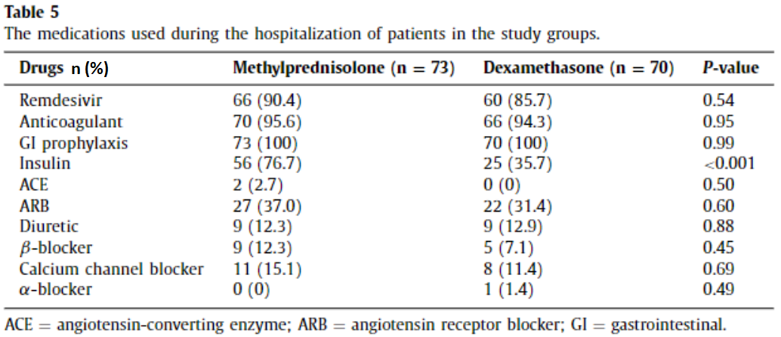
- Copy the table above in word.
- Copy the table below and fill in the answers for the following question
- Are there statistically significant differences in the frequency of insulin used between subjects who received methylprednisolone and those who received dexamethasone?

Requirements | Answer
- Number of subjects who used insulin in the group that received methylprednisolone (usually, in tables for qualitative variables, the number of subjects is specified followed in parentheses by the percentage of subjects. In fact, this is indicated in the first row of the table, by n (%))
- Percentage of subjects who used insulin in the group that received methylprednisolone
- Number of subjects who used insulin in the group that received dexamethasone
- Percentage of subjects who used insulin in the group that received dexamethasone
- Specify which of the two groups (those who received methylprednisolone, or those who received dexamethasone), received more insulin in percentage terms
- Specify the name of the statistical test used
- Null hypothesis for the statistical test used to answer the question in exercise 1
- Alternative hypothesis
- Value of p
- Interpret the result of the statistical test for a threshold statistical significance of 0.05

SCENARIO 3
A study was conducted to identify potential risk factors for pulmonary embolism (PE) in patients diagnosed with COVID-19 [1]. Clinical characteristics at admission are presented in Table 1 stratified by the absence or presence of pulmonary embolism.
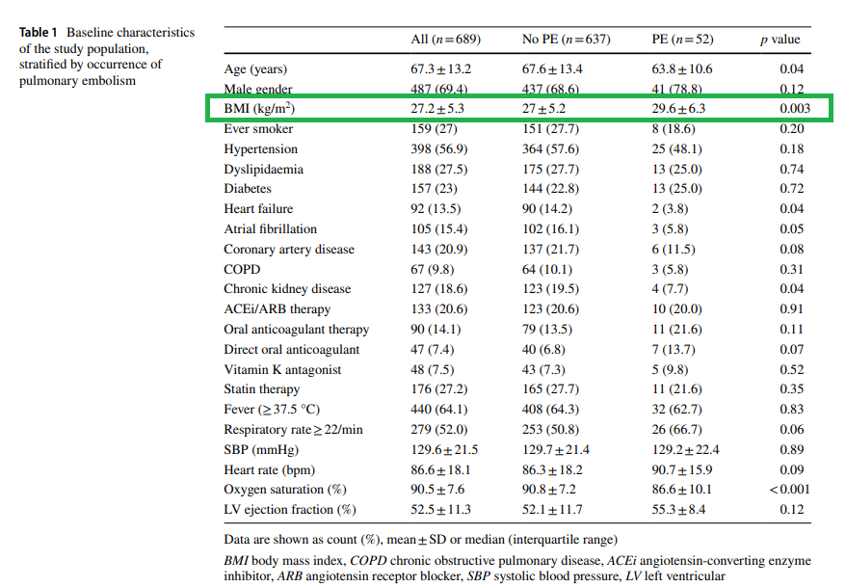
Requirement:
Considering the results in TABLE 1 (above), at a significance level of 5%, is there a statistically significant difference between the mean BMI (Body Mass Index) of COVID-19 patients who developed PE and COVID-19 patients without PE?
- Copy in word the table below and fill it in with your answers.
What we want to compare? | Answer
COVID-19 patients included in this study were divided according to:
a) a type of treatment
b) an exposure factor (e.g., sex)
c) a disease
Is the BMI variable a: continuous quantitative / discrete quantitative / dichotomous qualitative / nominal qualitative / ordinal qualitative variable?
Number of evaluated groups: 1, 2, or 3 groups?
Studied groups type:
a) independent groups (samples)
b) paired (dependent) groups (samples)

CHOOSING the APPROPRIATE STATISTICAL TEST | Answer
The parameters tested to identify differences in BMI are: Means/Medians/Frequencies
The appropriate statistical test is:
a) Student's t-test for independent groups
b) Student's t-test for dependent/paired groups
c) Test for variances

FORMULATION of HYPOTHESES for the APPROPRIATE STATISTICAL TEST | Answer
Which of the following hypotheses represents the null hypothesis associated with the research question?
a) There is no statistically significant difference between the mean BMI of the two subpopulations of COVID-19 patients those with PE and those without PE.
b) There is no statistically significant difference between the mean BMI of two samples of COVID-19 patients: one group with pulmonary embolism (PE) and the other group without.
c) There is no statistically significant difference between the median BMI of two samples of COVID-19 patients: one group with pulmonary embolism (PE) and the other group without.
d) There is no statistically significant difference between the BMI frequencies in COVID-19 patients with pulmonary embolism (PE) and those without (referring to the two subpopulations).

INTERPRETATION of the RESULTS of the STATISTICAL TEST | Answer
If the significance threshold is α = 0.05, make the correct interpretation of the p-value (from Table 1) of the test that compared the BMI means for the two populations:
• If p < 0.05 → we reject the null hypothesis (H0) → we are in favor of the alternative hypothesis (H1): There is a statistically significant difference between the BMI means of the two subpopulations of COVID-19 patients (those with PE and those without PE).
• If p ≥ 0.05 → the null hypothesis (H0) is not rejected→ We do not have enough evidence to conclude whether there is a statistically significant difference between the BMI means in COVID-19 patients with PE and those without PE.

EDUCATIONAL RESOURCES ONLINE
Function CHISQ.TEST on the Microsoft website.

