PUNCTUAL ESTIMATORS AND CONFIDENCE INTERVALS
Cosmina Ioana Bondor, Andrada Urda-Cîmpean

Educational objectives
At the end of this practical work, be able to:
- Evaluate the normality of the data using the histogram and descriptive statistics indicators
- Calculate the confidence interval of the mean and interpret it
- Calculate the confidence interval of the frequency and interpret it
- Calculate the relative risk confidence interval and interpret it
SCENARIO
To evaluate the characteristics of the young people (18-25 years) who suffer of scoliosis, the following data were collected: IDPac, Type pf scoliosis (congenital / idiopathic / neuromuscular / syndromic), Gender (F / M), Age (years), Cobb’s Angle (degrees), Prosthesis (with / without), Pain (yes / no), BMI (kg/m²). The data are available in DB-Scoliosis.xlsx file.
REQUESTS
- Download ad open DB-Scoliosis.xlsx file on your computer
CONFIDENCE INTERVAL FOR MEAN
- Create a distribution chart for BMI
- Interpret the chart by answering the questions in Table 1:
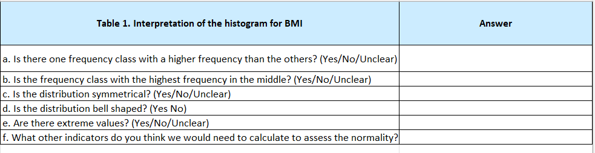
- Compute and complete in Table 2 the punctual estimators for BMI
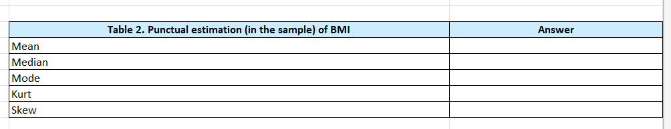
- Decide if BMI follows the normal distribution by answering the questions in Table 3
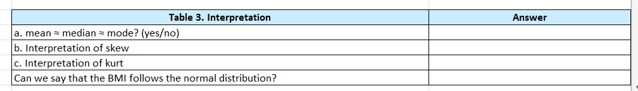
- Calculate the 95% confidence interval (95%CI) for the mean of the BMI variable (estimate the mean of the BMI variable in the population of 18–25-year-olds with scoliosis based on the sample mean) and write the results in Table 4. Use the following formulas:
Lower bound of the 95%CI:
$\overline{X}$ - Z_{α/2}*SE
Upper bound of the 95%CI:
$\overline{X}$ + Z_{α/2}*SE
If is needed: SE=$\frac{s}{\sqrt{n-1}}$
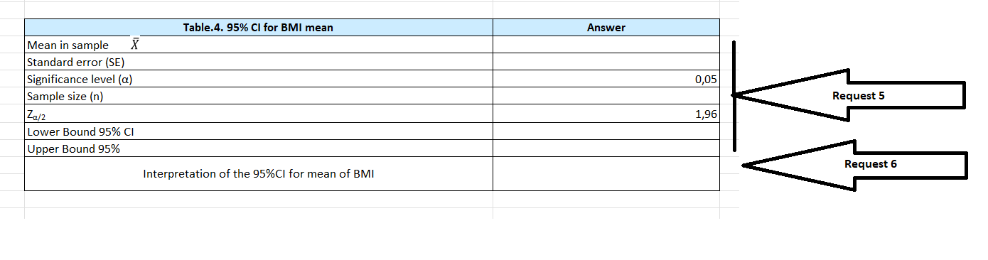
- Identify the correct answer (see Course 8) and complete the interpretation of 95%CI for mean of BMI in table 4:
- The mean of BMI for the people in the sample is in the range [25.45; 26.74] with a probability of 95%
- With 95% probability, the average BMI of the population of young people (18-25 years) with scoliosis is between 25,45 and 26,74
- We can state with an error of 5% that the average BMI of the population of young people aged 18-25 with scoliosis is between 25,45 and 26,74.
CONFIDENCE INTERVAL FOR FREQUENCY
- Create a chart to present the association between the variable Pain and Prosthesis.
- Calculate the frequency of the subjects who wear a prosthesis and complain of pain due to scoliosis.
- Calculate the 95% confidence interval for the frequency of subjects who wear a prosthesis and complain of pain due to scoliosis (estimate the frequency of pain in those who wear a prosthesis as a treatment for scoliosis in the population of 18–25-year-olds based on the sample frequency) in table 5. Use the following formulas to calculate the boundaries of the confidence interval:
Lower bound of the 95%CI:
$f$ - Z_{α/2*}$SE$
Upper bound of the 95%CI:

$f$ + Z_{α/2*}$SE$
Where f- frequency of subjects who wear a prosthesis and complain of pain due to scoliosis, n- sample size (how many subjects wear a prosthesis), and standard error SE = $\sqrt{\frac{f(1-f)}{n}}$.
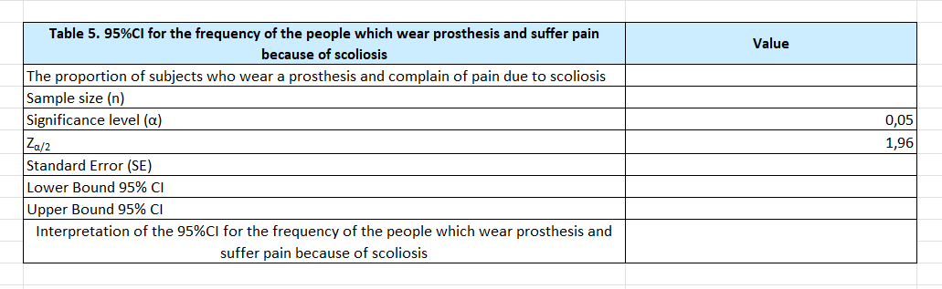

- Identify the correct interpretation of 95%CI for the frequency of subjects who wear a prosthesis and complain of pain due to scoliosis and complete the answer in the last cell of Table 5
- The proportion of subjects who wear a prosthesis and complain of pain due to scoliosis in the sample is between 18% and 40% with a probability of 95%
- We are 95% confident that the proportion of subjects who wear a prosthesis and complain of pain due to scoliosis in the population of young people aged 18-25 with scoliosis is between 18% and 40%
- We can say with an error of 5% that the proportion of subjects who wear a prosthesis and complain of pain due to scoliosis in the population of young people between 18-25 years old with scoliosis is between 18% and 40%

CONFIDENCE INTERVAL FOR RISK RATIO
- Calculate the risk ratio that an 18- to 25-year-old with scoliosis will have pain if he has a prosthesis compared to an 18- to 25-year-old with scoliosis who does not have a prosthesis using the instrument available on: https://statpages.info/ctab2x2.html
In the contingency table, place the PAIN on columns and PROSTHESIS on rows. Interpret the results.

