Normal distribution: Identifying the normal distribution of data using graphical representations and descriptive statistics

Sorana D. Bolboacă, Mihaela Iancu, Cosmina Ioana Bondor
SOLUTIONS

- To use the predefined functions see the instructions of the practical work Descriptive statistics-quantitative variable.

- 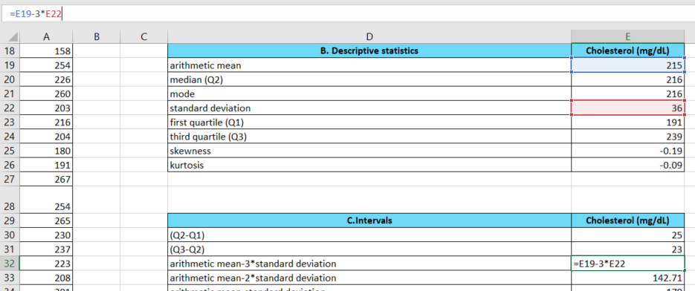
- Principles of evaluating the normal distribution of data. We expect to have a normal data distribution if all the conditions below are met:
- Arithmetic mean ≈ median ≈ mode
- (Q2-Q1) ≈ (Q3-Q2)
- When the asymmetry coefficient has a value in the interval [-1, 1]
- When the kurtosis coefficient has a value in the interval [-1, 1]
How to interpret the results?
- Please respond "yes" to this question if you believe that the arithmetic mean, median, and mode are approximately equal. In this context, we can say that the difference between these measures is negligible when compared to the variance in the data for this variable. However, if the mode differs significantly from the other two measures, and we are dealing with a continuous variable with decimal values, then the mode can be considered unimportant in making our decision, especially if the sample size is not sufficiently large to produce repeated values.
- Please respond "yes" to this question if you believe that the (Q2-Q1) ≈ (Q3-Q2) are approximately equal. In this context, we can say that the difference between these measures is negligible when compared to the variance in the data for this variable.
- When the asymmetry coefficient has a value in the interval [-1, 1] we can say that the distribution of the data is near symmetrical, else is asymmetrical.
- If you respond with „yes” to the first two questions and with „symmetry” to the third than choose „Yes”, else choose „No” to this question.
- A skewness coefficient less than -1 indicates a left-skewed (with negative asymmetry) series and with possible extreme cases in the left part of the distribution. A skewness coefficient greater than 1 indicates a right-skewed (with positive asymmetry) series and with possible extreme cases in the right part of the distribution.
- When the kurtosis coefficient has a value in the interval [-1, 1] we can say that the data have a mesokurtic distribution, the same as normal distribution is. A kurtosis coefficient less than -1 indicates a platikurtic series. A kurtosis coefficient greater than 1 indicates a leptokurtic series.
- If you respond with „yes” to the fourth questions and „mesokurtic” to the sixth than choose „Yes”, else choose „No” to this question.

- To meet the requirements we will use a combination of two predefined functions, COUNTIFS and COUNT.
Below is the exemplification for requirement a):
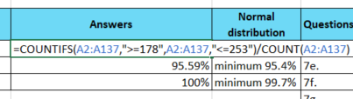
where A2:A137 is the area where we have the cholesterol values.
To answer questions d) – f) consult the Course Probability distributions.
To answer questions g), if you respond with „yes” to d), e) and f) questions than choose „Yes”, else choose „No” to this question.

