Normal distribution: Identifying the normal distribution of data using graphical representations and descriptive statistics
Sorana D. Bolboacă, Mihaela Iancu, Cosmina Ioana Bondor

Educational objectives
At the end of this practical work, the student will be able to:
- identify symmetry or normality of data distribution with the help of graphic representation (histogram)
- calculate descriptive statistics
- to identify based on descriptive statistics (arithmetic mean, median, modulus; symmetry, skewness; Q2-Q1 vs. Q3-Q2) whether the data distribution approximates the normal probability distribution
- calculate percentages based on a normal distribution using empirical rules
SCENARIO
The lipid profile of patients hospitalized in March 2022 in the internal ward of a hospital in Cluj County (Dej) was evaluated. We collected the following variables from the patients' medical records: age (years), sex (F/M), weight (kg), height (cm), heart rate (HR/min), systolic blood pressure (SBP) (mmHg), diastolic blood pressure (PAD) (mmHg), blood glucose (mg/dL), cholesterol (mg/dL), triglycerides (TG) (mg/dL)), HDL (mg/dL), length of hospital stay (days).
The collected data is available in the file LP7_BD-DateSpitalizare.xlsx).
Requirements
- Download the file LP7_BD-DateSpitalizare.xlsx.
Exercices 1.
- In the Cholesterol sheet represent the Cholesterol in a chart (histogram).
Add to the graph the number of subjects for each class interval, the title of the axes and units of measurement (if necessary) and the title of the graph.
- Please evaluate the histogram for the Cholesterol variable in the same sheet by answering the questions in the table titled "A. Interpreting the Histogram." Choose your responses from the options provided in columns E of the same spreadsheet.
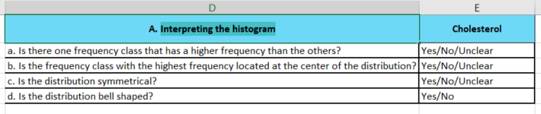
- In the Cholesterol sheet, calculate the centrality indicators (arithmetic mean, median, module), dispersion (standard deviation), location (first quartile and third quartile), and measures of symmetry (skewness, kurtosis) for the Cholesterol variable for the entire group. The calculation of the above indicators should be done in the table titled „B. Descriptive statistics” available in columns D-E of the same spreadsheet:
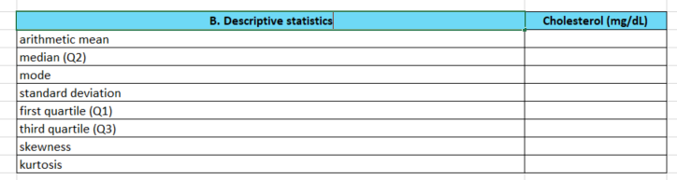
- In the same sheet, calculate the following formulas in the table titled „C. Intervals” available in columns D-E of the same spreadsheet:
(Q2-Q1)
(Q3-Q2)
arithmetic mean-3*standard deviation
arithmetic mean-2*standard deviation
arithmetic mean-standard deviation
arithmetic mean+standard deviation
arithmetic mean+2*standard deviation
arithmetic mean+3*standard deviation
where Q1, Q2, Q3, arithmetic mean and standard deviation are the indicators calculated before for the Cholesterol variable for the entire group
- Evaluate in the same sheet the calculated indicators for Cholesterol variable to determine if Cholesterol follows a normal distribution, using the statistical indicators calculated previously. Please include your interpretations in the same spreadsheet, in the table titled „D. Interpretations” available in columns G-H of the same spreadsheet. Q1 represents the 1st quartile, Q2 represents the median, and Q3 represents the 3rd quartile.
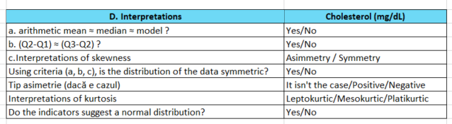
- In the table titled „E. Questions” available in columns G-H of the same spreadsheet
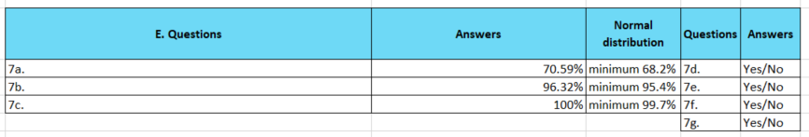
answer to the following questions:
  - What is the percentage of patients whose cholesterol value is in the range [arithmetic mean-standard deviation; arithmetic mean+standard deviation]?
  - What is the percentage of patients whose cholesterol value is in the range [arithmetic mean-2*standard deviation; arithmetic mean+2*standard deviation]?
  - What is the percentage of patients whose cholesterol value is in the range [arithmetic mean-3*standard deviation; arithmetic mean+3*standard deviation]?
  - According to the properties of the normal distribution (column I in Excel - see the lectures or search online), is the percentage of Cholesterol values ​​that we found between: arithmetic mean+standard deviation and arithmetic mean+standard deviation enough to consider that the data follow the normal distribution?
  - According to the properties of the normal distribution (column I in Excel - see the lectures or search online), is the percentage of Cholesterol values ​​that we found between: arithmetic mean+2*standard deviation and arithmetic mean+2*standard deviation enough to consider that the data follow the normal distribution?
  - According to the properties of the normal distribution (column I in Excel - see the lectures or search online), is the percentage of Cholesterol values ​​that we found between: arithmetic mean+3*standard deviation and arithmetic mean+3*standard deviation enough to consider that the data follow the normal distribution?
  - Using the answers that you give at d), e) and f) respond to the question: Does the Cholesterol distribution have the same properties as the normal distribution?
Exercices 2.
Repeat the request from 2) to 7) for TG variable in TG spreadsheet.
Optional. Exercices 3.
Repeat the request from 2) to 7) for HDL variable in HDL spreadsheet.

TO REMEMBER!
o Calculated values ​​of the mean, median, mode, skewness coefficient, and kurtosis can tell us whether or not we can expect a normal distribution of the data.
o Histogram allows us to visualize how the data are distributed.

ONLINE EDUCATIONAL RESOURCES

MODE.MULT
COUNTIFS
COUNT
NORM.DIST

