Hints for practical activity: ELEMENTS OF PROBABILITY THEORY

1.To find out the size of the sample we will count (for example) the number of numerical values ​​contained in the data table on the column Age (years), with the help of the COUNT function (figure 1) and we will display this result in a cell located below the table containing the data.
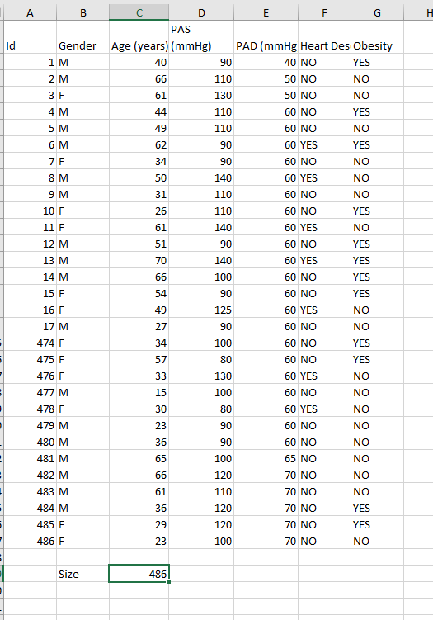
Figure 1. Computing sample size

2.To find out these probabilities, we will make the frequency table for the Gender variable, using the PivotTable. We will have the results in a new worksheet that we call Gender.

The probability that a random person in the sample is male will be calculated as the ratio of the number of males to the size of the sample. Analogously, the probability that randomly choosing a person from the sample is female will be calculated as the ratio of the number of female persons to the size of the sample

3.We will introduce a new item in the table header - MINOR. This new variable will have the set of values ​​composed of the values ​​{MINOR, MAJOR}. For each person in the sample, we will decide which of the values ​​will be associated with them, based on the value of that person's age. If the age is lower than 18, we will assign the value MINOR to that record otherwise the value MAJOR. Performing this operation for the first record in the table using the IF function is described in figure 2.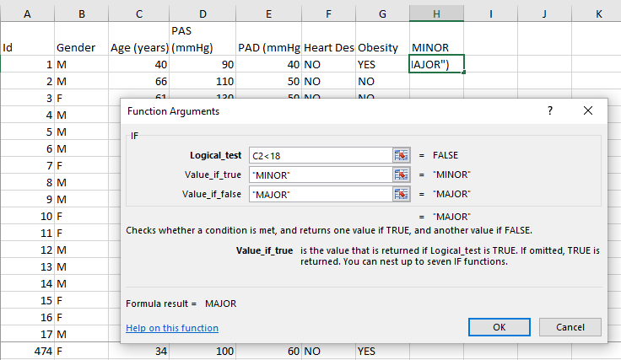
Figura 2. Using IF function for the MINOR / MAJOR decision – the first record
We replicate the function for all records in the table and then create the frequency table for the MINOR variable and calculate the required probability as the ratio of the number of people who are NOT minors to the sample size

4. We will enter for the first person in the table the value of the diagnostic test, taking into account that her systolic pressure is located in cell D2 and the value to be compared is 130. We will use the IF function.

We replicate the function for all records.
We make the contingency table between Heart Disease and TEST using the PIVOT TABLE tool. On the columns we will have the presence or absence of heart disease (variable Cardiac disease) and on the lines the result of the test (positive or negative – variable TEST). We check that the order in the table is HEART DISEASE – YES then NO respectively TEST – POSITIVE then NEGATIVE. Sort the contingency table - if necessary - to have the result in figure 3

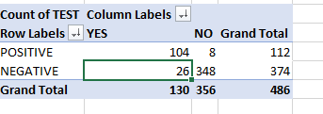
Figure 3. Contingency table between HEART DISEASE and TEST

According to the data in this contingency table we have the following values:
• real positives = 104
• false positives = 8
• false negatives = 26
• real negatives = 348
• total people with heart disease = 130
• total people without heart disease = 356
• total positive tests = 112
• total negative tests = 374
Sensitivity (the conditional probability that a diagnostic test will be positive knowing that it has been applied to a person who is sick) will be calculated as the number of true positives relative to the number of people with heart disease.
Specificity (the conditional probability that a diagnostic test would be negative given that it was applied to a person free of the disease) will be calculated as the number of true negatives relative to the number of people without heart disease.
Positive predictive value (conditional probability that a sick person is correctly identified with a positive test) will be calculated as the number of true positives divided by the number of positive tests.
Negative predictive value (conditional probability that a disease-free person is correctly identified with a negative test) will be calculated as the number of true negatives divided by the number of negative tests..

5. To calculate the required probabilities, we will need to construct the contingency table for the variables Gender and Obesity – see the previous exercise. It will be of the form shown in figure 4.
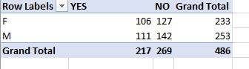
Figure 4. GENDER and OBESITY contingency table
The probability that a randomly selected person from the sample will be an obese woman will be calculated as the ratio of the number of obese women (106) to the total number of people in the sample (486)
The probability that one of the men is not obese at random will be calculated as the ratio of the number of men who are not obese (142) to the total number of men (253)
6. We will introduce a new variable in the table header – Aged 65 or older. This new variable will have the set of values ​​​​{YES, NO}. For each person in the sample, we will decide which of the values ​​will be associated with them, based on the value of that person's age. If the age is lower than 65, we will assign the value YES to that record otherwise the value NO. Use the IF function.
To calculate the relative risk we will need to construct the contingency table for the variables TYPE 2 DIABETES and AGED 65 OR OLDER – see the previous exercises. It will be of the form shown in figure 5. We check that the order in the table is TYPE 2 DIABETES – positive then negative respectively AGED 65 OR OLDER – YES then NO. Sort the contingency table - if necessary - to have the result in figure 5.
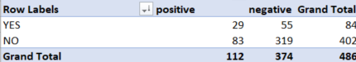
Figure 5. TYPE 2 DIABETES and AGED 65 OR OLDER contingency table
Calculate the relative risk (RR) by dividing the probability of Type 2 diabetes in people older or equal to 65 years and the probability of Type 2 Diabete in people younger than 65 years.
Interpret the obtained results using the following rules:
RR = 1 ⟶ the age over 65 is not a risk factor for Type 2 Diabetes
RR > 1 ⟶ age over 65 increas the risk of Type 2 Diabetes.
RR < 1 ⟶ age over 65 decrease the risk of Type 2 Diabetes
7. Resolve a similar exercise. We will calculate, based on the data in the sample, what is the probability that an adult will have heart disease. We’ll use the Pivot Table (MINOR and HEART DESEASE)– see figure 6
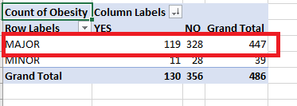
Figure 6. Prevalence of cardiac disease on adults
From the total of 447 adults, 119 have cardiac disease, so Pr(A) = 119/447 = 0.27.
We know that Pr(B) = 0.2 (“20% of adults are smokers”) and also Pr(A∩B)=0.25 (“25% of the adults who smoke have heart diseases”).
Pr(A)*Pr(B) = 0.27*0.2 = 0.054. Acording to the definition, two events are independent if and only Pr(A∩B) = Pr(A)*Pr(B). Here Pr(A∩B) ≠ Pr(A)*Pr(B) (0.25≠0.054), so the events are not independent.
IMPORTANT!
o Probability is a value between 0 and 1
o Relative frequency can be seen as an empiric probability function

ONLINE EDUCATIONAL RESOURCES
Create frequency table in Excel using Pivot table - https://www.youtube.com/watch?v=pjy9DJ2gcV8
Create contingency table in Excel using Pivot table - https://www.youtube.com/watch?v=OijjAgrPJ8Y

