SOLUTIONS

2. Calculate the absolute frequency for the presence of symptoms at discharge using the =CountIf(range, criteria) function. Then for the absence of symptoms at discharge. Add them together using the =SUM(range) function.
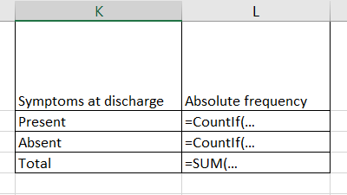
3. A. From the data table (columns A-H), select the Discharge Symptoms column heading (cell H1). Insert a pivot table from the Insert Menu – Pivot Table. Press OK.
Obs. Make sure the entire data table is selected in the Table /Range field. If it is not, then select it.

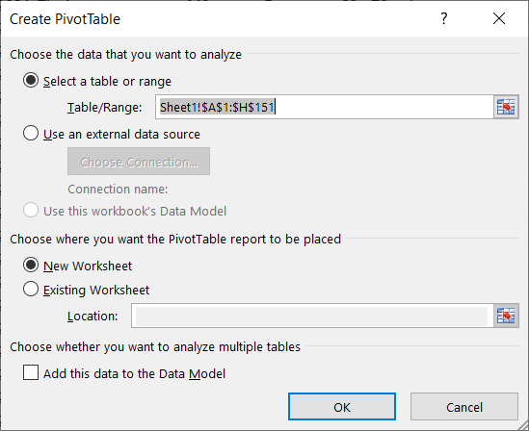
B. Once you press OK, the following tool will be inserted on a new page in the Excel file:
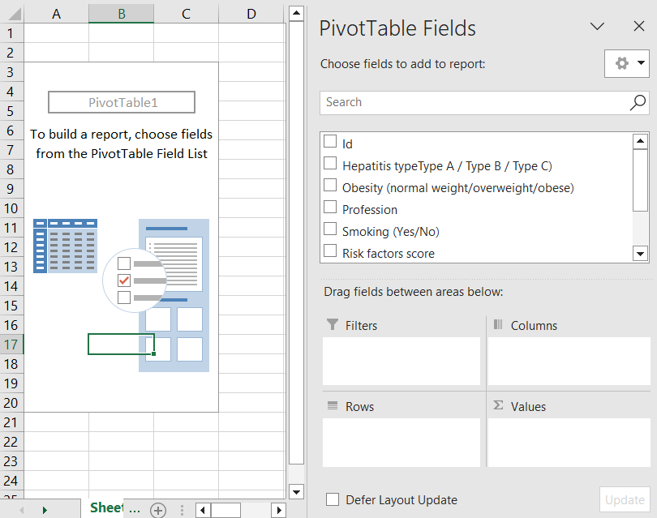
C. Using the mouse Drag and Drop the Discharge Symptoms variable over the ROWS area of ​​the lower right table. Then drag the Discharge Symptoms variable again over the Σ Values ​​area in the lower right corner.
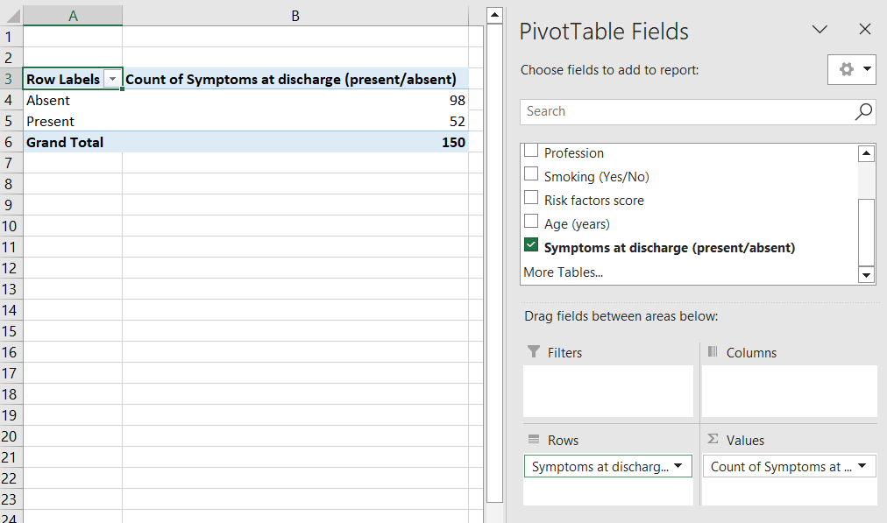
Optional: Videos on Microsoft page: How to use PivotTable in Excel
!Check: The frequencies obtained are the same as those obtained with the CountIf function.
Interpretation:
• "In the studied group of 150 individuals, 52 individuals had some symptoms present at discharge."
• "In the studied group of 150 individuals, 98 individuals had no symptoms at discharge."

4. A. Select the previously created frequency table and insert a Pie chart from the Insert – Pie Chart menu.
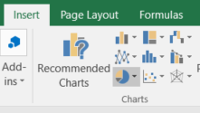
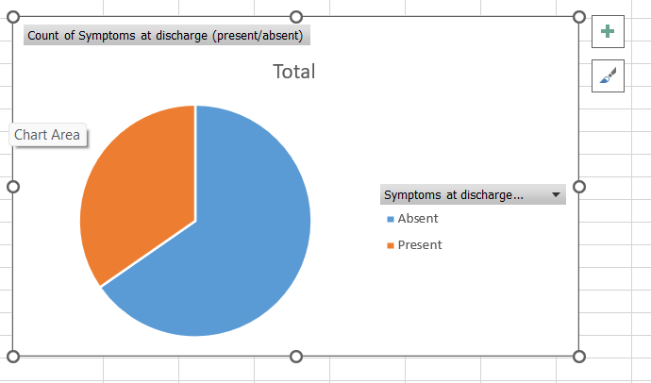
B. Add the percentages and the title (Symptoms at Discharge) to the graph. Percentages are found by clicking the + button at the top right of the graph, the Data Labels option, then More Options, check Percentages. To change the title, click on it and change the text with a more suitable one.

Optional: Videos on the Microsoft Page: How to Create a Chart in Excel Create a Pie, Bar or Line Chart
! A Pie chart is a percentage representation, it would be desirable to have the percentages for each category displayed.
Interpretation:
• "In the studied group, 35% of the individuals had some symptoms present at discharge."
• "In the studied group, the relative frequency of individuals with symptoms present at discharge was 35%."
• "In the studied group, 65% of the individuals had no symptoms at discharge."
5. A. Proceed similarly to point 2 to calculate the frequency table with the Pivot Table option. Go back to the first page, the one with all the data. Select the Risk Factor Score column heading. Insert from the Insert Menu – Pivot Table. Drag the Risk Factor Score variable over the Rows and over the Σ Values ​​area.
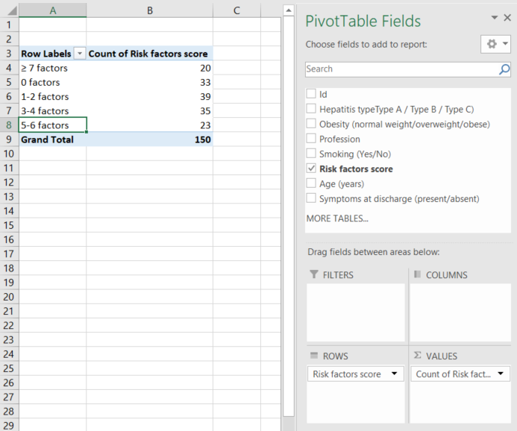
B. Drag the category ≥ 7 factors to the last place by selecting that cell and dragging its edge down until it is where we want it.
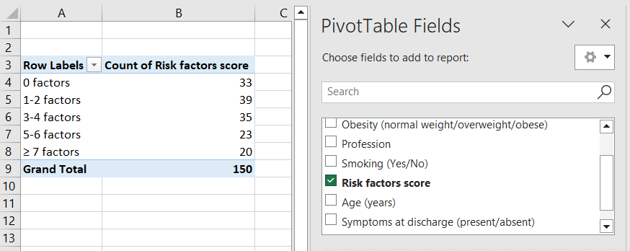
C. Select a cell in the created pivot table and insert a Column or Bar graph from the Insert Menu.
D. Change the title to a more appropriate one. Add the absolute frequencies to the columns using the + button in the upper right corner of the graph by checking Data labels. Add axis titles using the + button in the upper right corner of the graph by checking Axis Titles. Enter the headings from the requirements on each individual axis. Delete the legend. At the end the graph will look like this:
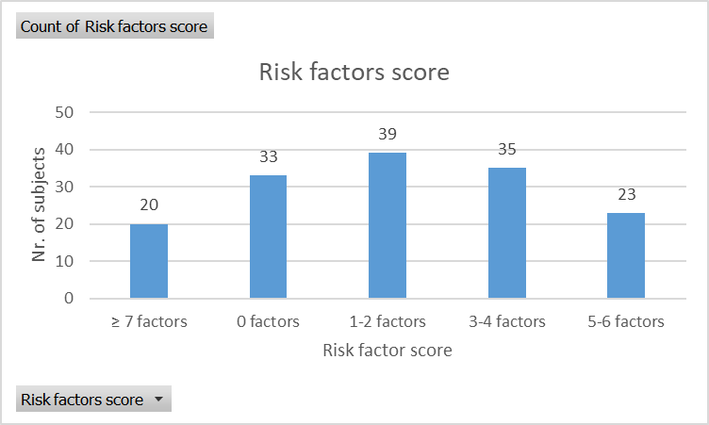

6. A. Proceed similarly to point 2 to calculate the frequency table with the Pivot Table option. Return to the data table page. Select the Smoker column heading. Insert from the Insert Menu – Pivo t Tables. Drag the Smoker variable over the Rows and over the Σ Values ​​area.
B. Drag the Obese variable over the Columns area at the bottom right of the window.
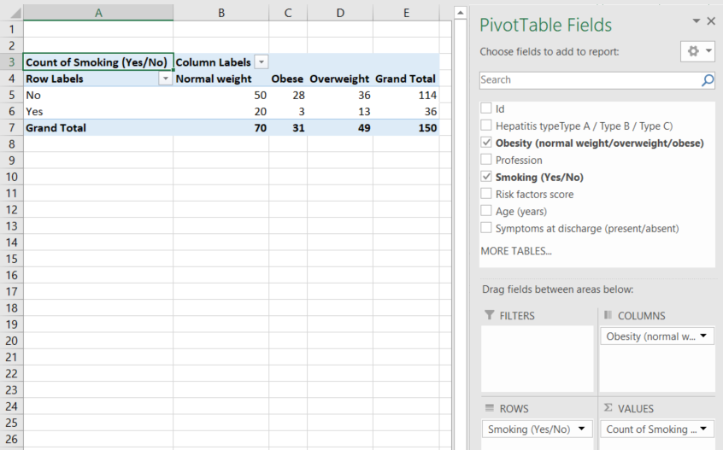
C. Change the order of the obese and overweight categories in their order according to the severity of obesity: normal weight (no obesity), overweight (body weight above the normal limit), obese (obesity present).
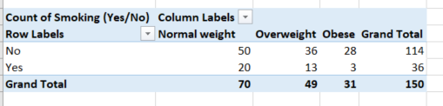
Obs. This is the contingency table for the relationship between the Smoker variable and the Obese variable.
Interpretation:
• "In the studied group of 150 individuals, 20 are normal weight and smokers".
• "In the studied group of 70 normal-weight individuals, 20 are smokers."
• "In the studied group of 36 smokers, 20 are normal weight".
Obs. The contingency table is the most widely used statistical analysis tool in medical data analysis. If the relationship between a risk/protection factor and the disease is analysed, then the Condition (Disease or Effect) is entered in the Columns area, and the Risk Factor (Cause) is entered in the Rows area. If a new diagnostic test is being evaluated, then the Standard Test (Disease or Effect) is entered in the Columns area, and the New Diagnostic Test is entered in the Rows area.
7. A. Select the frequency table. Insert a Stacked Column or Stacked Bar chart.
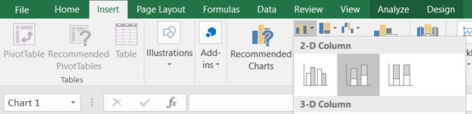
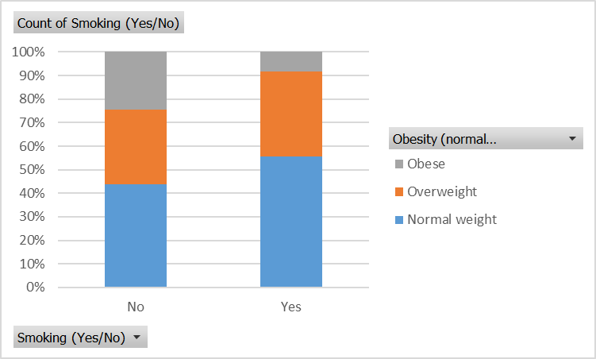
It is more interesting to compare the categories of obesity than the categories of smokers. To switch axes use the Switch Row/Column button in the Design menu.
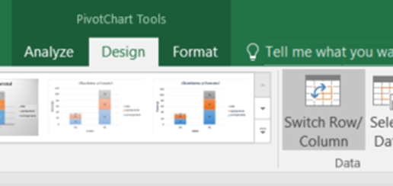
At the end the graph should look like this:
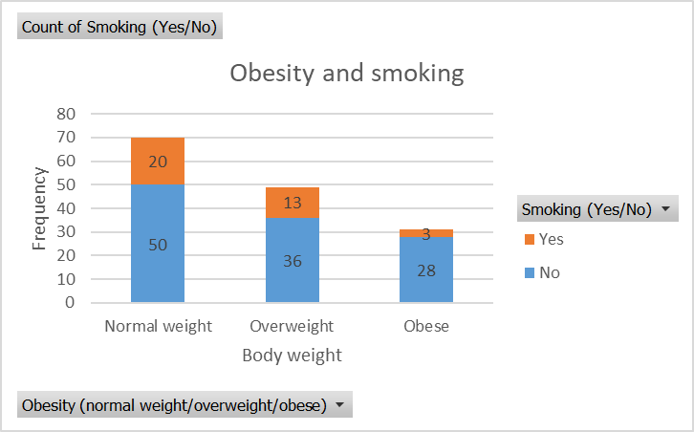
8. A. Make a contingency table for the variables Obese and Profession similar to the one built in point 7. Place Profession in the Rows area and Obese in the Columns area. Either of the two variables can be drawn in the Σ Values ​​area.
B. Insert a 100% Stacked Bar chart.
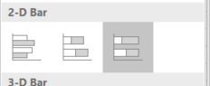
C. Add to the graph the absolute frequencies, the title of the axes (Ox – County, Oy – Percentages) and the title of the graph (Obesity and profession).
The final graph will look like this:
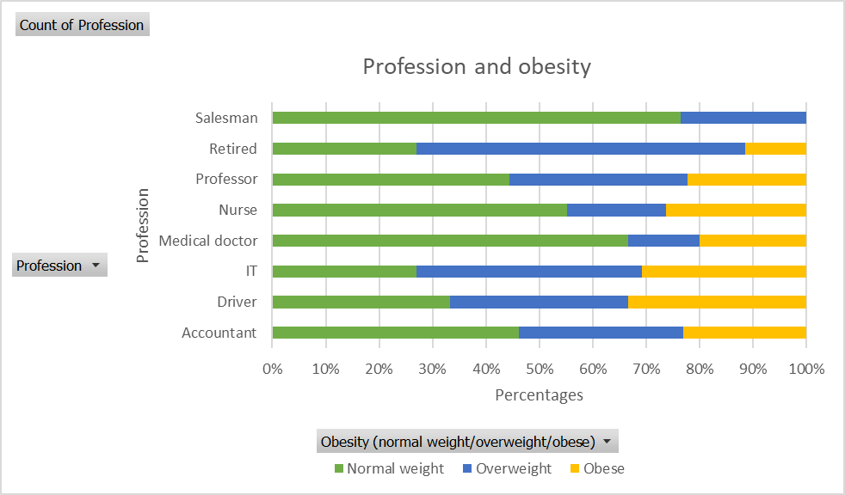
Interpretation:
• "The highest percentages of obese and overweight people are pensioners and people working in IT".
• "The lowest percentage of obese people was among people who work as sellers."
• "The highest percentage of obese people was among people who work as drivers".

ONLINE EDUCATIONAL RESOURCES
Videos on the Microsoft page: https://support.microsoft.com/ro-ro/excel
How to use PivotTable in Excel
How it is created a chart in Excel
Create a Pie, Bar or Line chart

