To remember:

- All laboratory files MUST be saved in your server partition (a folder on the server). This operation is only possible if you have been cataloged to your department's network using your personal user and password.
- If you save your work into the folder with your name (in Users… My Documents), these files will not be found on your server partition; moreover, folders in My Documents will be deleted once a week / month.
- PAY ATTENTION WHEN YOU SAVE YOUR DOCUMENTS!!!
- File and folder names must be in accordance with the requirements.
Create Excel file
- Create a new Excel file [Taskbar - Search - Search for Excel - button for New Document].
Save the file
- Saving the document: [File - Save As - Browse - This PC - your own partition - Lab01 folder].
Rename spreadsheet
- Right-click the default name of the selected sheet (for example, Sheet1 - is located at the bottom of the spreadsheet) + Rename
Insert spreadsheet into the same file:
- Toolbar: Insert Sheet option
Change the length of a column/line
Drag the line between two columns / lines. Columns: if you want to change the length of column A, drag to the right the line between A and B columns). Lines: if you want to change the length of line 1, drag down the line between lines 1 and 2).
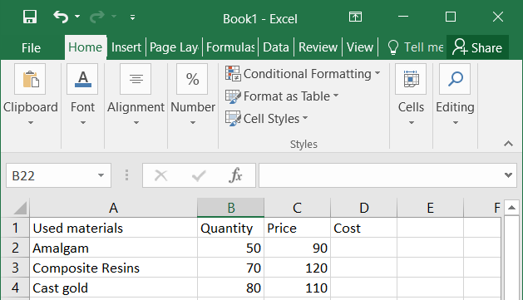
Insert a new column into the database (at the right of the column with TAD values, at the left of Blood Glucose)
- Select the Blood Glucose column (i.e. the column next to the TAD variable) and use the Insert Sheet Columns option (from the toolbar)
Introducing a calculation formula using relative and / or absolute references
Definitions: Relative reference of a cell in an Excel spreadsheet: is the "cell name". A cell is referred to by the column and line name on which it is located: A1 (column A line 1), AZ10 (AZ column, line 10).
Excel formulas are constructed using arithmetic operators and references to cells containing operand values.
If a formula contains relative references, this means that when you copy the formula to another cell, Excel will change the cell reference to which the formula refers to according to the position of the cell in which the formula was copied;
An absolute reference refers to a fixed location in the spreadsheet and will be symbolized by the use of the dollar sign "$" in front of the line name of the column representing the constant cell name (e.g. $F$19). If a formula contains absolute references, it means that when you copy the formula to another cell, Excel will not modify the absolute cell reference.
In Excel we have the following arithmetic operators:
- addition: +,
- subtraction: -,
- multiplication: *,
- division: /,
- exponentiation: Keyboard Symbol ^ (Shift 6)
- percentages: %
!!! Do not use {} and [] in writing formulas. Only round brackets () are used.
Introducing the COST formula:
- Select a blank cell where you want to enter the formula (for example, for the formula COST, the cell selected will be D2 = the first free cell in the newly created column, the cell containing the value of the first material's COST;
!!! A formula in Excel always starts with the writing of the equality sign = after which the formula is adapted to the corresponding cell references: for example, in the case of the formula COST we have: = B2*C2, where B2 represents QUANTITY of the first patient and C2 represents the PRICE value of first dental material
- To extend the same formula to the rest of the dental materials: select the desired field (in the case of COST: select all cells from D2 to D13) and choose the Fill-Down option in the toolbar.
CAREFUL!!!! The height value should be converted from cm to m so that the formula IMC becomes
= F2 / (G2 / 100) ^ 2
Introducing the calculation formula for the cost of consultation
- In cell C4 will represent the first patient's consultation cost, the formula introduced here being of the form: = B4 * $C$1, where B4 represents the numbers of consultations for the first patient, C1 represents the consultations cost (constant for all patients)
- Generalize the formula for the rest of the patients: select the desired field (all cells from C4 to C15 are selected) and choose the Fill-Down option in the toolbar.
Exercise 4
- In Cell A1 write: "Hospitalization Cost per Day". Select cells from A1 to C1 and Merge Cells from these cells to create one cell.
- In cell A3 write: Gender (M/F). After you Enter the text, select the A3 cell and Wrap the text in two row in the cell


